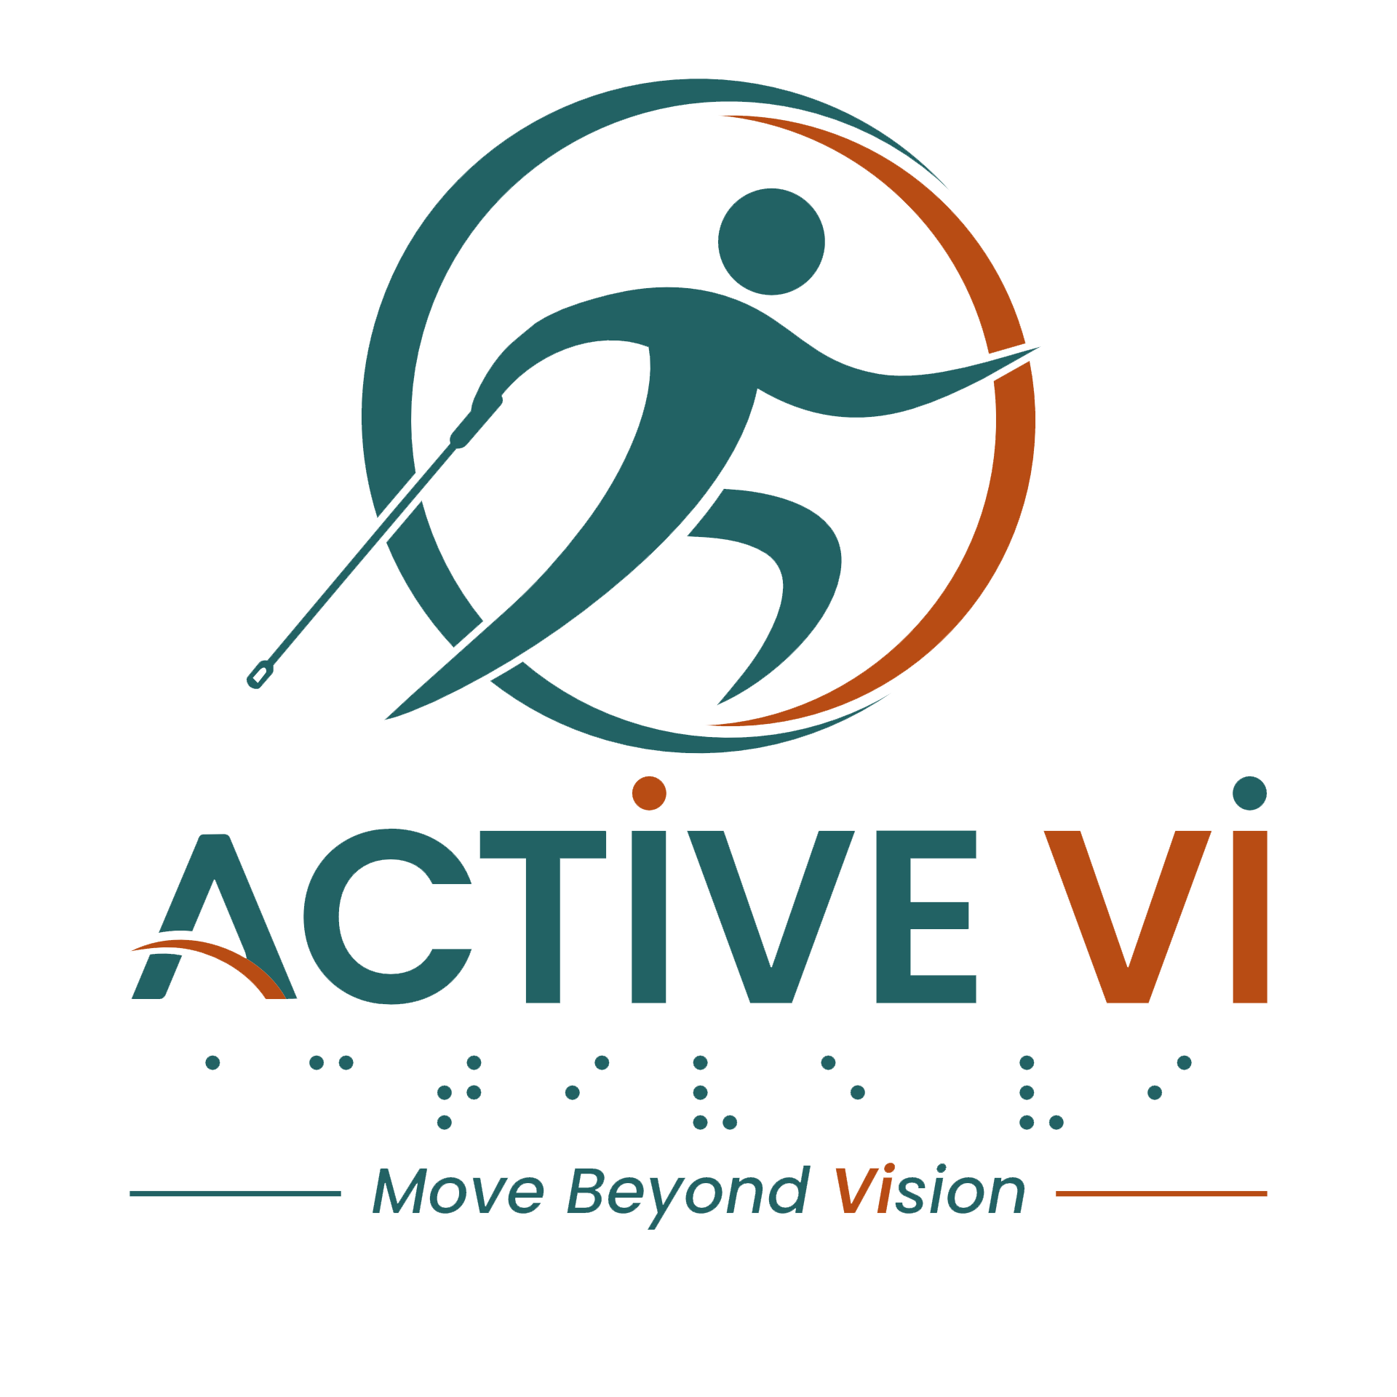

Transcript: The ACTIVE VI VOLUNTEER Journey - Shared Goals, Mutual Growth
Duration: 3.07 mins
Watch the Video: The ACTIVE VI Volunteer Journey: Shared Goals, Mutual Growth on YouTube.

[Background Music]
[Visual: ACTIVE VI - Move Beyond Vision logo appears on screen along with the website www.activevi.sg. The title text reads: VOLUNTEER Journey - Shared Goals, Mutual Growth.]
[Visual: A crowded CrossFit gym where volunteers and ACTIVE VI participants are working out together. A female volunteer, Eileen, is guiding a female participant, Verlyn, with a barbell movement. A coach can be heard counting repetitions in the background.]
[Visual: Eileen Tay, a Volunteer, is speaking to the camera. Cutaways show her guiding Verlyn on a rowing machine and doing core exercises together on the floor.]
Eileen Tay: I've always wanted to volunteer. So when Sam opened up this opportunity, right, so I find it really meaningful. Because for me, I do exercise quite regularly, we do exercise quite regularly, so I thought this is a good opportunity to also put what we learn, our fitness, to help others, uplifting the community.
[Visual: Verlyn, an ACTIVE VI Participant, speaks to the camera. Cutaways show her using a SkiErg machine while being supported and encouraged by Eileen and other volunteers.]
Verlyn: There is always support at this CrossFit gym. I feel that my volunteer and Uncle Sam has always been very supportive, encouraging, and they know exactly what they are doing.
[Visual: Participants and volunteers are doing squats and cable pull exercises. A male volunteer, Lee Wei Keong, is guiding a male participant, Teh Lin, through a SkiErg machine workout.]
[Visual: Lee Wei Keong and Eileen Tay, both Volunteers, stand together outdoors speaking to the camera.]
Lee Wei Keong: You know, it's not just like gathering and we are just doing the session. Community also because same purpose, everybody has fitness in mind. Number two, also community because we are familiar with each other. There's a lot of laughter and stuff. So one of the things I always try to get Teh Lin to be familiar with, I always give him that neck massage, back massage, then he will squirm.
[Visual: Cutaway of Lee Wei Keong jokingly giving Teh Lin a shoulder massage in the gym, causing Teh Lin to laugh and pull away playfully.]
[Visual: Teh Lin, an ACTIVE VI Participant, speaks to the camera. Cutaways show him performing exercises with a barbell and a PVC pipe, guided by Lee Wei Keong and other volunteers.]
Teh Lin: For this CrossFit, I feel that it's actually very inclusive for us, with visual impairment.
[Visual: Colin, a Volunteer, speaks to the camera. Cutaways show him guiding a male participant, BK, on the SkiErg and throwing wall balls together.]
Colin: I've been volunteering for about, gosh, coming up on eight months now, right since the very beginning of the programme. And I think what's kept me here for sure is just watching the progress. How powerful these individuals are, right? There's no limitations that they have. So it's really exciting to watch them progress over these last months, to go from very introductory to people like BK that are competing in Hyrox events now. So it's so rewarding to see that progress.
[Visual: Participants and volunteers are seen jogging together outside the gym building.]
[Visual: Bee Guan, a Volunteer, speaks to the camera. Cutaways show her guiding a female participant, Jamie, through exercises using a PVC pipe and a SkiErg.]
Bee Guan: Being a volunteer is always a two-way. So with the VIs here, we are actually here to help them with the workout. So actually, along the way, we learn as well. How to give instructions, how to perfect all the movements and everything. So along the way, we are also learning as well. And also to encourage them to work out. So as we work out with them, they feel more fun working out together also. Yeah.
[Visual: Jamie, an ACTIVE VI Participant, speaks to the camera. Cutaways show her performing pull-ups and stretches with verbal guidance and physical support from Bee Guan and others.]
Jamie: The volunteers that are in this gym, they are very friendly, and although they are not professional trainers, but they do give us a lot of guidance as to how to move our body, our hands and legs, and to correct our posture as well if we do it incorrectly.
[Visual: Eileen Tay and Lee Wei Keong smile and speak directly to the camera together, pumping their fists.]
Eileen Tay & Lee Wei Keong: ACTIVE VI, move beyond vision!
[Music: ACTIVE VI - Move Beyond Vision Jingle]
[Visual: The ACTIVE VI - Move Beyond Vision logo appears on screen along with the website www.activevi.sg.]
[Visual: The End Credits display on screen: Led by Singapore Institute of Technology (SIT) Health and Social Sciences. In Collaboration with Guide Dogs Singapore and Singapore Association of the Visually Handicapped (SAVH). Supported by Enabling Lives Initiative (ELI) Grant by SG Enable & Tote Board. Text displays the grant and copyright disclaimer: The video was produced by Enabling Lives Initiative Grant, with support from SG Enable. It is not to be reproduced in part or in whole, without the written permission of Tote Board and/or SG Enable.]
[Visual: Text displays: Special Thanks to: Participants and volunteers who contributed to the project, FireCity, Everyone supporting inclusive fitness and community connection.]
[End of transcript]

ABOUT ACTIVE VI: MOVE BEYOND VISION
ACTIVE VI is a movement co-designed with persons with visual impairment (PVI), fitness professionals, and volunteers to promote inclusive physical activity. We empower everyone to build inclusive fitness environments and support our community to Move Beyond Vision.

CONNECT WITH US & ACCESS RESOURCES
- Visit the ACTIVE VI Website & Adaptive Sports Directory
- Watch the ACTIVE VI YouTube Channel
- Listen to the ACTIVE VI Podcast on Spotify

