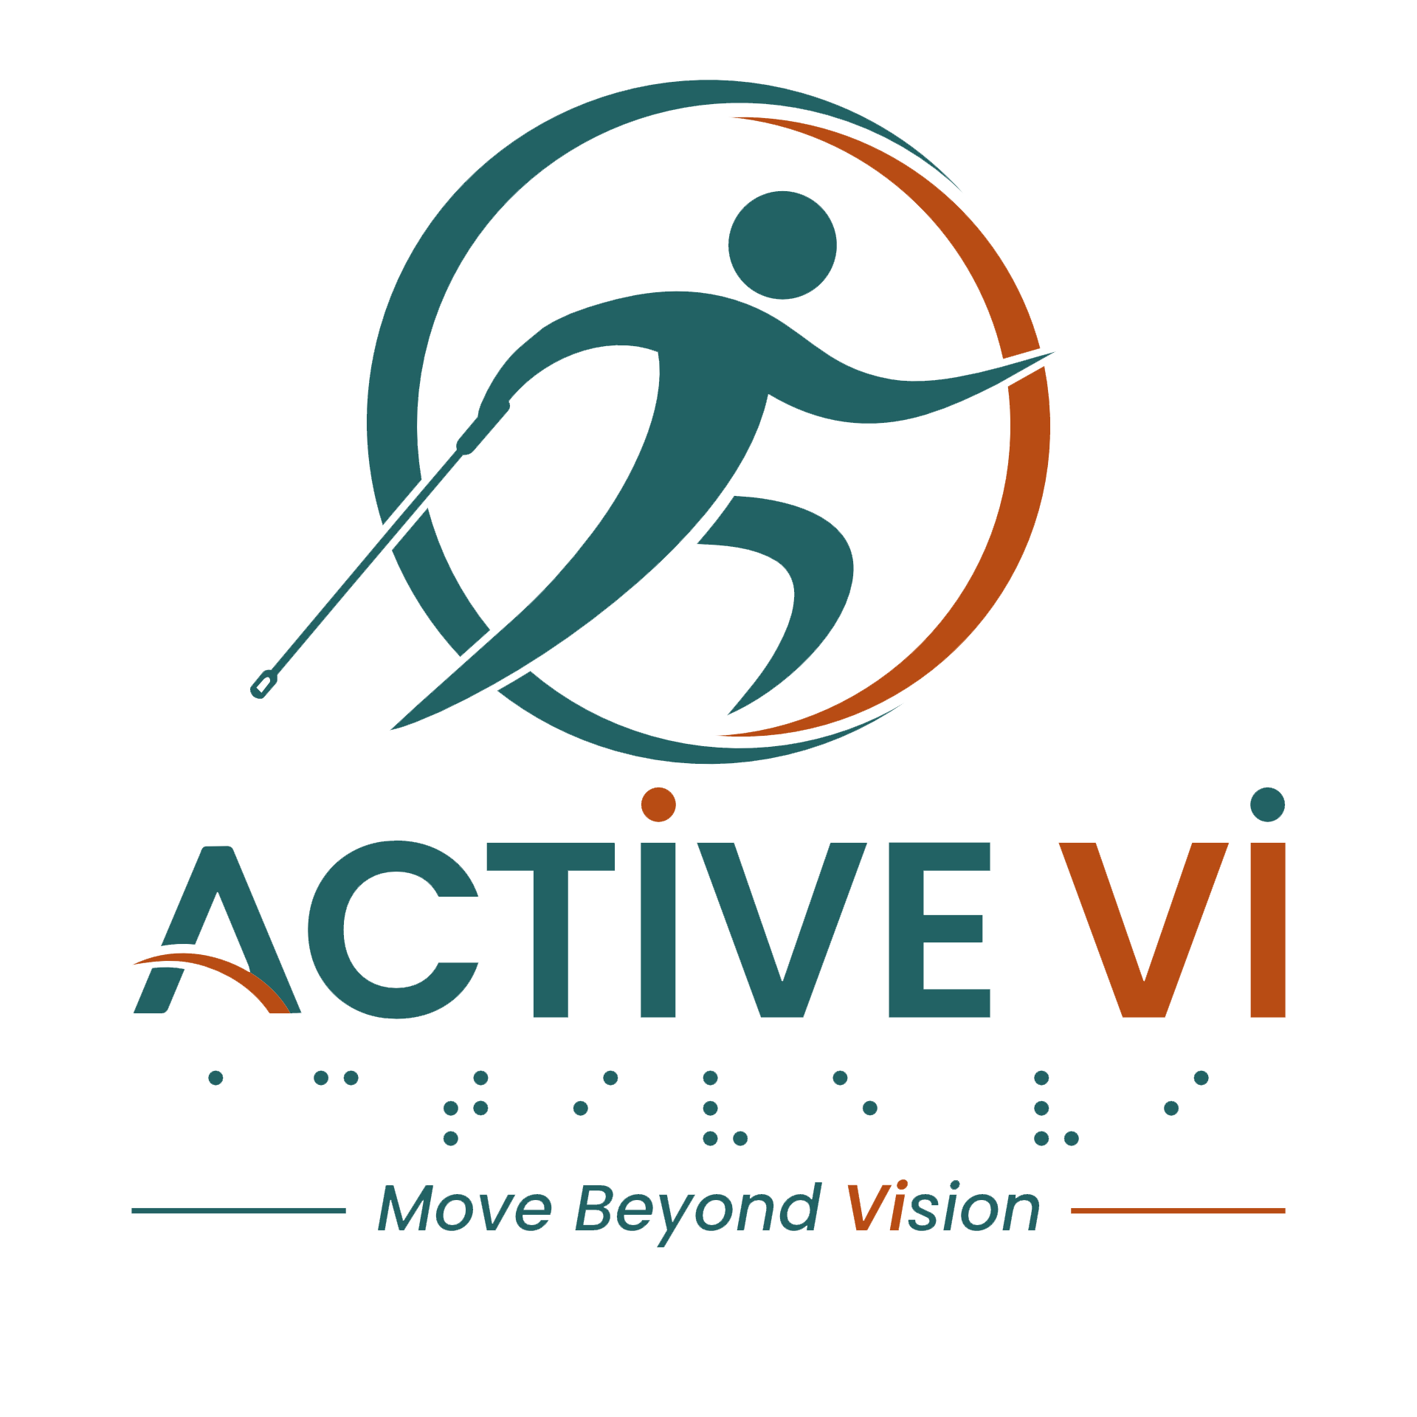

Transcript: Sight Guiding VI Techniques – The Do’s and Don’ts
Duration: 2.45 mins
Watch the Video: The Sight Guiding Techniques – The Do’s and Don’ts on YouTube.

[Background Music]
[Visual: ACTIVE VI - Move Beyond Vision logo appears on screen along with the website www.activevi.sg. The title text reads: SIGHT GUIDING VI TECHNIQUES - The Do's and Don'ts.]
[Visual: Teh Lin, an ACTIVE VI Participant, is walking through an MRT station guided by an SMRT staff member.]

Teh Lin (Voiceover): A SMRT staff guiding me through the gantry and clearly telling me where we are heading to.
[Visual: The SMRT staff gently guides Teh Lin's hand to touch a notice board on the wall to orient him.]
Teh Lin (Voiceover): He placed my hand on the notice board and I know that this is the reference point and telling me where I am, and I really appreciate it.
[Visual: Simon Teh, a volunteer, walks up to Teh Lin.]
Simon: Hi.
Teh Lin: Hi. Er…
Teh Lin (Voiceover): Introduce yourself. Or I won’t know who you are.
[Visual: Simon approaches Teh Lin again to demonstrate the correct way to introduce himself.]
Simon: Hi Teh Lin, my name is Simon. I'm a volunteer. I'll bring you to the gym today.
Teh Lin: Oh hi Simon. Nice to meet you.
Simon: So would you like to take my hand, my elbow or my shoulder?
Teh Lin: Oh, how about your left elbow?
Simon: Sure.
[Visual: Simon offers his left elbow, and Teh Lin gently holds onto it just above the joint.]
Teh Lin (Voiceover): It really helps if you tell me your name and ask me how I would like to be guided.
[Visual: Simon demonstrates the wrong way to guide. He walks up abruptly and pulls on Teh Lin's sleeve.]
Simon: Hi Teh Lin, I'm a volunteer. I'll bring you to the gym. Come.
Teh Lin (Voiceover): Please don't pull my sleeve or pull my cane. It will make me feel very sudden and make me very confused. Please check that I am ready to go.
[Visual: Simon demonstrates the correct way, stopping to verbally check if Teh Lin is ready to move.]
Simon: We'll take a walk now?
Teh Lin: Sure. Thank you.
Simon: Thank you.
[Visual: Simon demonstrates another incorrect technique by suddenly grabbing and pulling Teh Lin's white cane.]
Teh Lin: Please don't pull my cane. That's my GPS!
[Visual: Simon and Teh Lin are walking towards an escalator in the station.]
Simon: We are approaching escalator going up.
Teh Lin (Voiceover): When approaching the escalator, please let me know whether the escalator is moving up or down, so that I can prepare myself and place my hand on the handrail when I'm near to it.
[Visual: Simon demonstrates the wrong way to approach the escalator by stopping abruptly without warning, causing Teh Lin to bump into him.]
Teh Lin (Voiceover): Please let me know when we are approaching the escalator and please do not stop suddenly.
[Visual: The two of them approach a zebra crossing outdoors.]
Teh Lin (Voiceover): When approaching a zebra crossing, please let me know in advance so that we can get ready to slow down and stop.
[Visual: They are now walking along a paved footpath bordered by grass.]
Simon: Okay there's a shoreline on your left.
Teh Lin (Voiceover): When walking along a footpath, please let me know so that I can use my cane to swipe and feel the edge of the path.
[Visual: They approach a set of outdoor concrete stairs.]
Simon: Okay we are approaching steps ah.
Teh Lin (Voiceover): Let me know if there are steps and tell me if it's going up or going down.
Simon: Okay we are approaching four steps.
Teh Lin: Okay. Broad steps ah.
Simon: Okay. One...
[Visual: They carefully step up the stairs together as Simon counts.]
Teh Lin (Voiceover): Let me know the number of steps and tell me before the start and ending steps.
[Visual: They arrive at a heavy glass door.]
[Visual: Simon demonstrates the wrong way by opening the door and pulling it directly towards Teh Lin without warning him to step back.]
Simon: Oh, sorry, I opened up the door.
Teh Lin (Voiceover): Please let me know if the door is swinging towards me so that I can get ready and move backward.
[Visual: Simon demonstrates the correct way to handle the swinging door.]
Simon: Okay we are approaching a glass door. It's going to swing towards us. Please step back. Okay, let’s go.
[Visual: They enter the gym facility, and stop in the workout area.]
Simon: Okay we are here, Teh Lin. Thank you for walking with me.
Teh Lin: Thank you Simon for guiding me. Clear communication makes a big difference.
[Visual: Text appears on screen: The ACTIVE VI logo and website www.activevi.sg reappear.]
[Music fades in: ACTIVE VI: Move Beyond Vision Transcript]
Teh Lin (Voiceover): Good sight guiding is about communication, respect and partnership. ACTIVE VI: Move Beyond Vision.]
[Music: ACTIVE VI: Move Beyond Vision Jingle fades in]
[Visual: The End Credits begin to display on screen.]
[Visual: Text displays: Led by Singapore Institute of Technology (SIT) Health and Social Sciences. In Collaboration with Guide Dogs Singapore and Singapore Association of the Visually Handicapped (SAVH). Supported by Enabling Lives Initiative (ELI) Grant by SG Enable & Tote Board. The grant and copyright disclaimer: The video was produced by Enabling Lives Initiative Grant, with support from SG Enable. It is not to be reproduced in part or in whole, without the written permission of Tote Board and/or SG Enable.]
[Visual: Text displays: Special Thanks to: Participants and volunteers who contributed to the project, SMRT Trains, Everyone supporting inclusive fitness and community connection.]
[Music Ends]
[End of transcript]

ABOUT ACTIVE VI: MOVE BEYOND VISION
ACTIVE VI is a movement co-designed with persons with visual impairment (PVI), fitness professionals, and volunteers to promote inclusive physical activity. We empower everyone to build inclusive fitness environments and support our community to Move Beyond Vision.

CONNECT WITH US & ACCESS RESOURCES
- Visit the ACTIVE VI Website & Adaptive Sports Directory
- Watch the ACTIVE VI YouTube Channel
- Listen to the ACTIVE VI Podcast on Spotify

