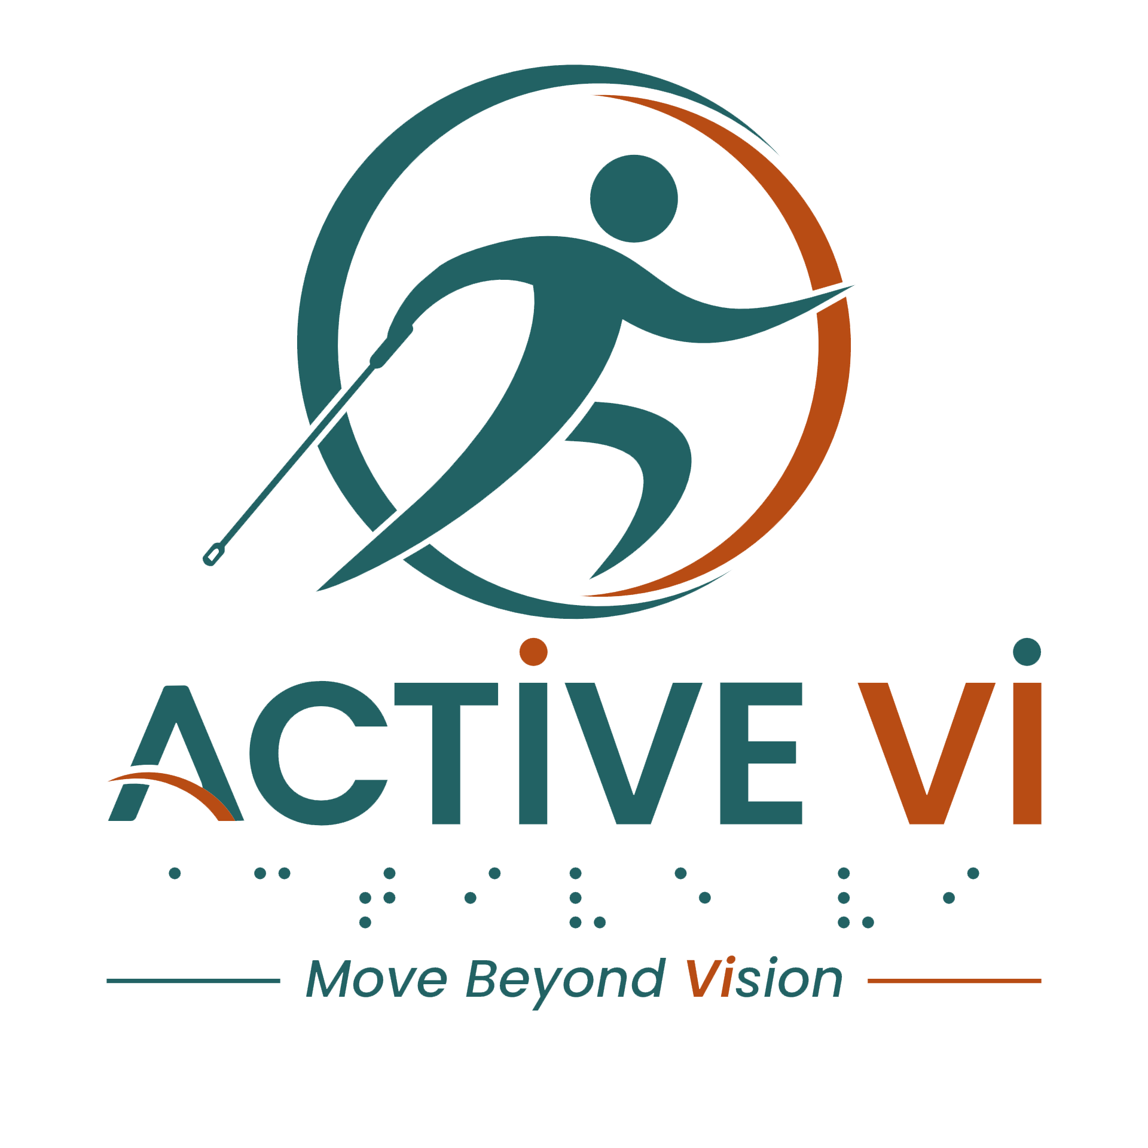

Podcast Episode 5 Transcript: Conquering Hyrox: Finding Strength and Moving Beyond Vision.
Duration: 15.51 minutes
Listen to this ACTIVE VI Podcast episode on Spotify.

[Music: ACTIVE VI - Move Beyond Vision Jingle]
[Music fades]
Jason: Hi, everyone. Welcome back to the podcast, Active VI Move Beyond Vision, where we spotlight stories, strengths, and everyday achievements of people with vision impairment living actively and fully in their own ways.
Today's episode is about courage, teamwork, and pushing limits because we are talking about Hyrox Racing for this episode.
For people who are not familiar with Hyrox, it's no joke and it's not for the faint-hearted. It is a very intense physical sports, which requires both physical endurance and mental toughness.
Today on our show, I've invited two of my very good friends, Dennard and Pei Pei.
Welcome, Dennard and Pei Pei.
Dennard: Hi, Jason, Pei Pei, and everyone. I'm Dennard here. It's my pleasure to be in this podcast to share more of my Hyrox experience with you guys.
Pei Pei: Thank you, Jason, and hi, Dennard, and hi, everyone.. I'm very honoured to be here but just a little bit nervous.
Jason: Okay, let our listeners get to know both of you. Let's start. Maybe, Dennard, you can share with us your eye condition?
Dennard: I have a very rare eye condition called cone rod dystrophy. In Singapore, I mean, as of to date, I know there's only three of us. My eyesight is quite similar to the condition called RP. For me, I can see blur vision. Yeah, so it's like pixelated vision.
Pei Pei: For me, my condition is retinitis pigmentosa, commonly known as RP.
My vision has deteriorated over the years, so at present, I have very poor visions. For instance, like Dennard is sitting beside me, I can still see a silhouette of him, and I can see that the rooms, there are lights, there are tables.
Jason: Okay, your condition is very similar to mine, Pei Pei. I understand both of you have just completed a Hyrox race in April. Maybe you can share with our listeners and myself how you all get into the Hyrox race. You'd like to start first, Pei Pei?
Pei Pei: Sure. I work out in this CrossFit gym called Fire City. So, one day my trainer, Samuel, affectionately known as Uncle Sam, asked me if I was keen to join him in Hyrox for the mixed doubles. So that was how it all came about.
Jason: And Dennard?
Dennard: For me, this is my second time joining this Hyrox. I used to run marathons a lot, like when I'm in my 20s, early 30s, and I haven't done so for more than 10 over years. Now being like visually impaired, got more volunteers help me in the activities. So, I decided to join marathon. One of my gym, NCSF, they actually introduced me to Hyrox. And I was like, wow, okay, it's something like marathon, but there's upper body training as well. So, to me, it's something new and I want to try that.
Jason: I understand your first race is a doubles and you did a solo this time.
Dennard: Yes, Jason.
Jason: What's the difference between these two?
Dennard: Doubles, you will have a partner with you. Running, we have to run together as a team. So, that 8 kilometer run, we all have to run together. But during the station, if I'm tired, my buddy can take over me. If I'm in a very tired state, right, my buddy can actually complete the whole functional exercise, then we can just go back and run together. But for solo, I will have to depend on myself, I will have to finish it all by myself.
Jason: Pei Pei, you did a mixed doubles this time. I understand for a mixed doubles, you have to carry a man's weight. [laughter]
Pei Pei: Yes, correct. That was initially what made me consider for a long time to actually say yes to Uncle Sam, especially after seeing the weights of the sleds, like the sled push, it was like three times my weight.
And the kettlebells that I'm supposed to lift was almost my weight. And lunging on a 20 kilograms sandbag, it just all sounds very mission impossible. And the wall ball was like 6 kilograms and you have to throw it to a 9 feet target.
Jason: Just to give our listeners some context, Pei Pei, can you share with us what's your height and weight?
Pei Pei: [laughter] Well, I can share the weight of the sleds. [laughter] The sled push was 152 kg.
Jason: And your weight?
Pei Pei: I am about 51 kilograms.
Jason: Wow [laughter]. And just now you mentioned the wall ball, you've got to throw, you've got to hit 27 feet, am I right?
Pei Pei: 9 feet.
Jason: 9 feet. Oh, 9 feet.
Pei Pei: 27 feet, that will be…
Jason: Okay, I got it wrong. And your height?
Pei Pei: 157.
Jason: Okay, that's amazing.
Dennard: So for me, I'm about the same size as Pei Pei. So…yah, it's actually not a very easy task for us to complete the race…the wall ball, all this sled push and push, and even more so with our vision, as of such.
Jason: I understand for Hyrox there are eight stations, functional workout stations, which one do both of you think is the most difficult for yourself? Can you share with us? Dennard, you’d like to go first?
Dennard: Definitely wall ball. I would think Pei Pei will agree more.
Pei Pei: Definitely.
Dennard: Yes, wall ball is the hardest.
Jason: Why is it so hard?
Dennard: We can't see the target and we can't really see the ball coming towards us. And in that ambience, you know, it’s very loud. People are cheering you, loud music, everything. You can't hear the bouncing of the ball, the sound of the ball. So you really have to depend on the momentum to actually catch the ball, which is very, very difficult.
And like what Pei Pei mentioned, throwing a 6 kg wall ball up to a 9 feet wall, for us, our height is actually very disadvantage.
Jason: How many times do you have to throw the ball? Is it just five or 10 times?
Pei Pei: No, for me it was, I can't recall, but definitely a lot less than 100. [laughter]
Jason: Okay, and Dennard you are doing your solo, you hit 100 times?
Dennard: I think I have throw like 200. Because a lot of misses; because of our eye condition, we can't really see the target. So we just keep throwing.
Pei Pei: Yes, I know. And then you can’t clearly hear because when you hit the ball, people are cheering.
Dennard: Yes, correct. Yes…
Pei Pei: Well, I was very tired by then. I didn't even try to catch the ball, so Uncle Sam was the one trying to deflect the ball away from me.
Dennard: Yes, you are right. I saw a lot of like Instagram video from passerby taking Sam deflecting the ball away from you. And they are very, very touched, where a guide helped a VI to complete this Hyrox race.
Jason: Then, Dennard, I'm curious, you're doing the solo, right? So, there are no protector for you, so you get hit 100 times by the wall ball.
Dennard: The guide still can protect me. The guide is actually beside me. He's a guide, but he's not a player. He's just doing it together with me, to support me in terms of bringing me to the station, helping me to check where's the wall ball, when I drop on the floor, he got to pick up for me and put in front of me and tell me where is it. So my guide actually is even more important because he's not doing the race, but he is willing to run together with me, to be my eyes in the race.
Jason: Is he the same guide that you partner with during your doubles?
Dennard: Yes, for us VI, we really need someone that we trust in, ya, we can believe in, to guide us. Because with that trust, with that belief that he can pull us through, we'll be more confident and we will be able to do our tasks on hand more easier.
Jason: What's your guide’s name?
Dennard: Desmond. We started off as strangers actually. He was not from NCSF. He was being invited by a NCSF volunteer to come and run with us. So, Desmond's speed is quite similar to mine. And his willingness to want to know more about how to guide me, give me that confidence to trust and believe in him. And he really go all out to learn how to guide me and think out of the box to see how best to guide me. And that really brings me to know that I can trust in him and can believe that he can see me through to the finishing line. And he did twice.
Ya, he's an amazing guide, really amazing guide.
They are not just volunteers, they are like a family to me. Wherever we have hiccups or we can't really train, they will find alternative place for us to continue our training. And to be honest, this Hyrox, this April Hyrox, I actually trained in five gyms.
Yes, five gyms, because our own gym, we can't really cater to Hyrox training. So they actually find others' gym, and those volunteers, they will give us additional training, you know, throughout this Hyrox, because we are very tight. So, they actually push us, they actually put in more days to train us. They use their own precious time for us to complete our race. So it's really a very, very, very amazing community to me.
Jason: Okay, and Pei Pei?
Pei Pei: I trained in Fire City, so I really appreciate Uncle Sam, you know, giving his time to give me one-to-one training. And I really like the vibe in Fire City because the community there, they are very warm and very friendly. So, it just makes me feel so welcome and comfortable and very touched.
Dennard: For me, I'm one of the few VI in my gym, and the most of them are from special needs, adult with special needs. And It's really a joy to be, training with them because they are all very special and very, very real people. And their expression, the way they react, all these things, it brought a lot of joy, a lot of happiness in the tough training that I have.
Jason: Dennard, actually, both of us joined the same gym, which is NCSF. So, when you share the vibe, you know, the support from the community, I actually relate very deeply with you because I feel personally very welcoming at that gym. So, it's like a big family.
What do you think has changed after this race?
Pei Pei: I mentioned at the start that fear was really one of the setbacks for me before saying yes. So, I think now I realise that actually probably I have more strength than I believe. So, I think a lot of great barriers actually exist in our minds. So, if we choose to push through them, we can overcome far more than we actually imagine.
Jason: The self-belief after completing this race.
Pei Pei: Yes, correct.
Jason: And Dennard, what about yourself?
Dennard: For me, I have stopped doing competitive races for more than 10 years. And that 10 years, actually, my eyesight started to deteriorate, confidence actually dropped drastically as my eyesight started to deteriorate. So, I don't know whether can I find the confidence back. But during these two Hyrox races and the encouragement from all my peers, my friends, my family, it brought so much joy and happiness back into my life. And it built a lot of confidence in me. That confidence is something that I used to have, I lost, but I found it again. So it's something very, very special to me.
Jason: So, with this, you know, charged confidence, what's next for you, Dennard?
[laughter]
Dennard: My full marathon. So, after these two Hyrox, I think I will still have to go with my desire to want to complete a full marathon.
Pei Pei: I can't imagine that.
Dennard: You must join me; it’s not you can't imagine that. Next one, okay, we run together.
Jason: For the benefit of our listeners, I understand the day after Dennard completed his Hyrox, he did a 10-kilometer run.
Pei Pei: Yes, he said that is a recovery run. My goodness! My understanding of recovery is to lay in bed and sleep.
Dennard: Okay, for me, running has always been a very happy part of my life. You know, when you're running, you feel very at peace. You don't think about the world. You think about just you and your breathing and the pace. And it actually bring a lot of like peace in me during the run.
Pei Pei: Maybe I'll start with 5 km.
Dennard: Okay, you can. I will still see you there.
Jason: Okay, yes, now we have it recorded.
So... five kilometers for you Pei Pei is your next target? I understand you also did cycling. What's next for you?
Pei Pei: Well, for cycling, we are having our national individual time trial next.
Jason: So, you are aiming to represent nationally for Singapore, like be it SEA Games? Or maybe even a bigger one, Paralympics?
Pei Pei: [laughter] Well, one step at a time, but let's see how far I can go.
Dennard: All the best.
Pei Pei: Thank you.
Jason: Well done, Pei Pei. So, if people who wanted to try Hyrox the first time, what both of you will advise him or her?
Dennard: Okay, for me, the VI community in Hyrox is very small. Only me, Pei Pei, BK, Valerie and Royston. So actually, just five of us competing. And we really need more of you all out there to come and join us, and you know, fight with us together. You know, Pei Pei, BK, they are really inspiration to me. I can move towards the finishing line also because I see the determination and motivation of you all, you know, the way they train, the way they are focused, like, wow, I really admire them, they really inspired me.
Jason: So how do you encourage someone who is still holding back?
Pei Pei: Well, I'd say, you don't have to be ready. You just need the courage to take the first step.
Dennard: I would just say sign up for the Hyrox race. Once you sign up, you pay the money, you cannot back up, and you just continue your training. I would say everybody can do it. (If) We can do it. Y'all of you can do it as well.
Jason: Great advice for anyone who feel inspired and would like to try Hyrox for the first time.
Pei Pei: So Jason, the next one will be you.
Dennard: [laughter] Yes, you!
Jason: Thank you so much.
Dennard: We are looking at you.
Pei Pei: We will be cheering and rooting for you.
Dennard: You are right.
Jason: Thank you so much. And thank you to our listeners. I think it's really great having both of you on our show. I can say I'm actually a bit inspired by both of you, really.
And for our listeners who also feel inspired as I am, maybe it's time for us to really breathe in, suck in the courage and make the first step. That's all for today.
Pei Pei: Thanks for having us here, Jason. I hope our sharing will inspire more VIs to participate in not only Hyrox but other activities and keep themselves active.
Dennard: Yes, come out, all of you. Ya, come and join activities. There's so much out there for the VI. So come and join us and just be part of the family. It's really a very happy and joyful family, training together as a team.
Jason: Thank you, Dennard and Pei Pei. And thank you to our listeners who are tuning in. We shall see you in the next episode of...
All: Active VI, move beyond vision.
[Music: ACTIVE VI - Move Beyond Vision Jingle]
[Music fades]
[End of transcript]

ABOUT ACTIVE VI: MOVE BEYOND VISION
ACTIVE VI is a movement co-designed with persons with visual impairment (PVI), fitness professionals, and volunteers to promote inclusive physical activity. We empower everyone to build inclusive fitness environments and support our community to Move Beyond Vision.

CONNECT WITH US & ACCESS RESOURCES
- Visit the ACTIVE VI Website & Adaptive Sports Directory
- Watch the ACTIVE VI YouTube Channel
- Listen to the ACTIVE VI Podcast on Spotify

