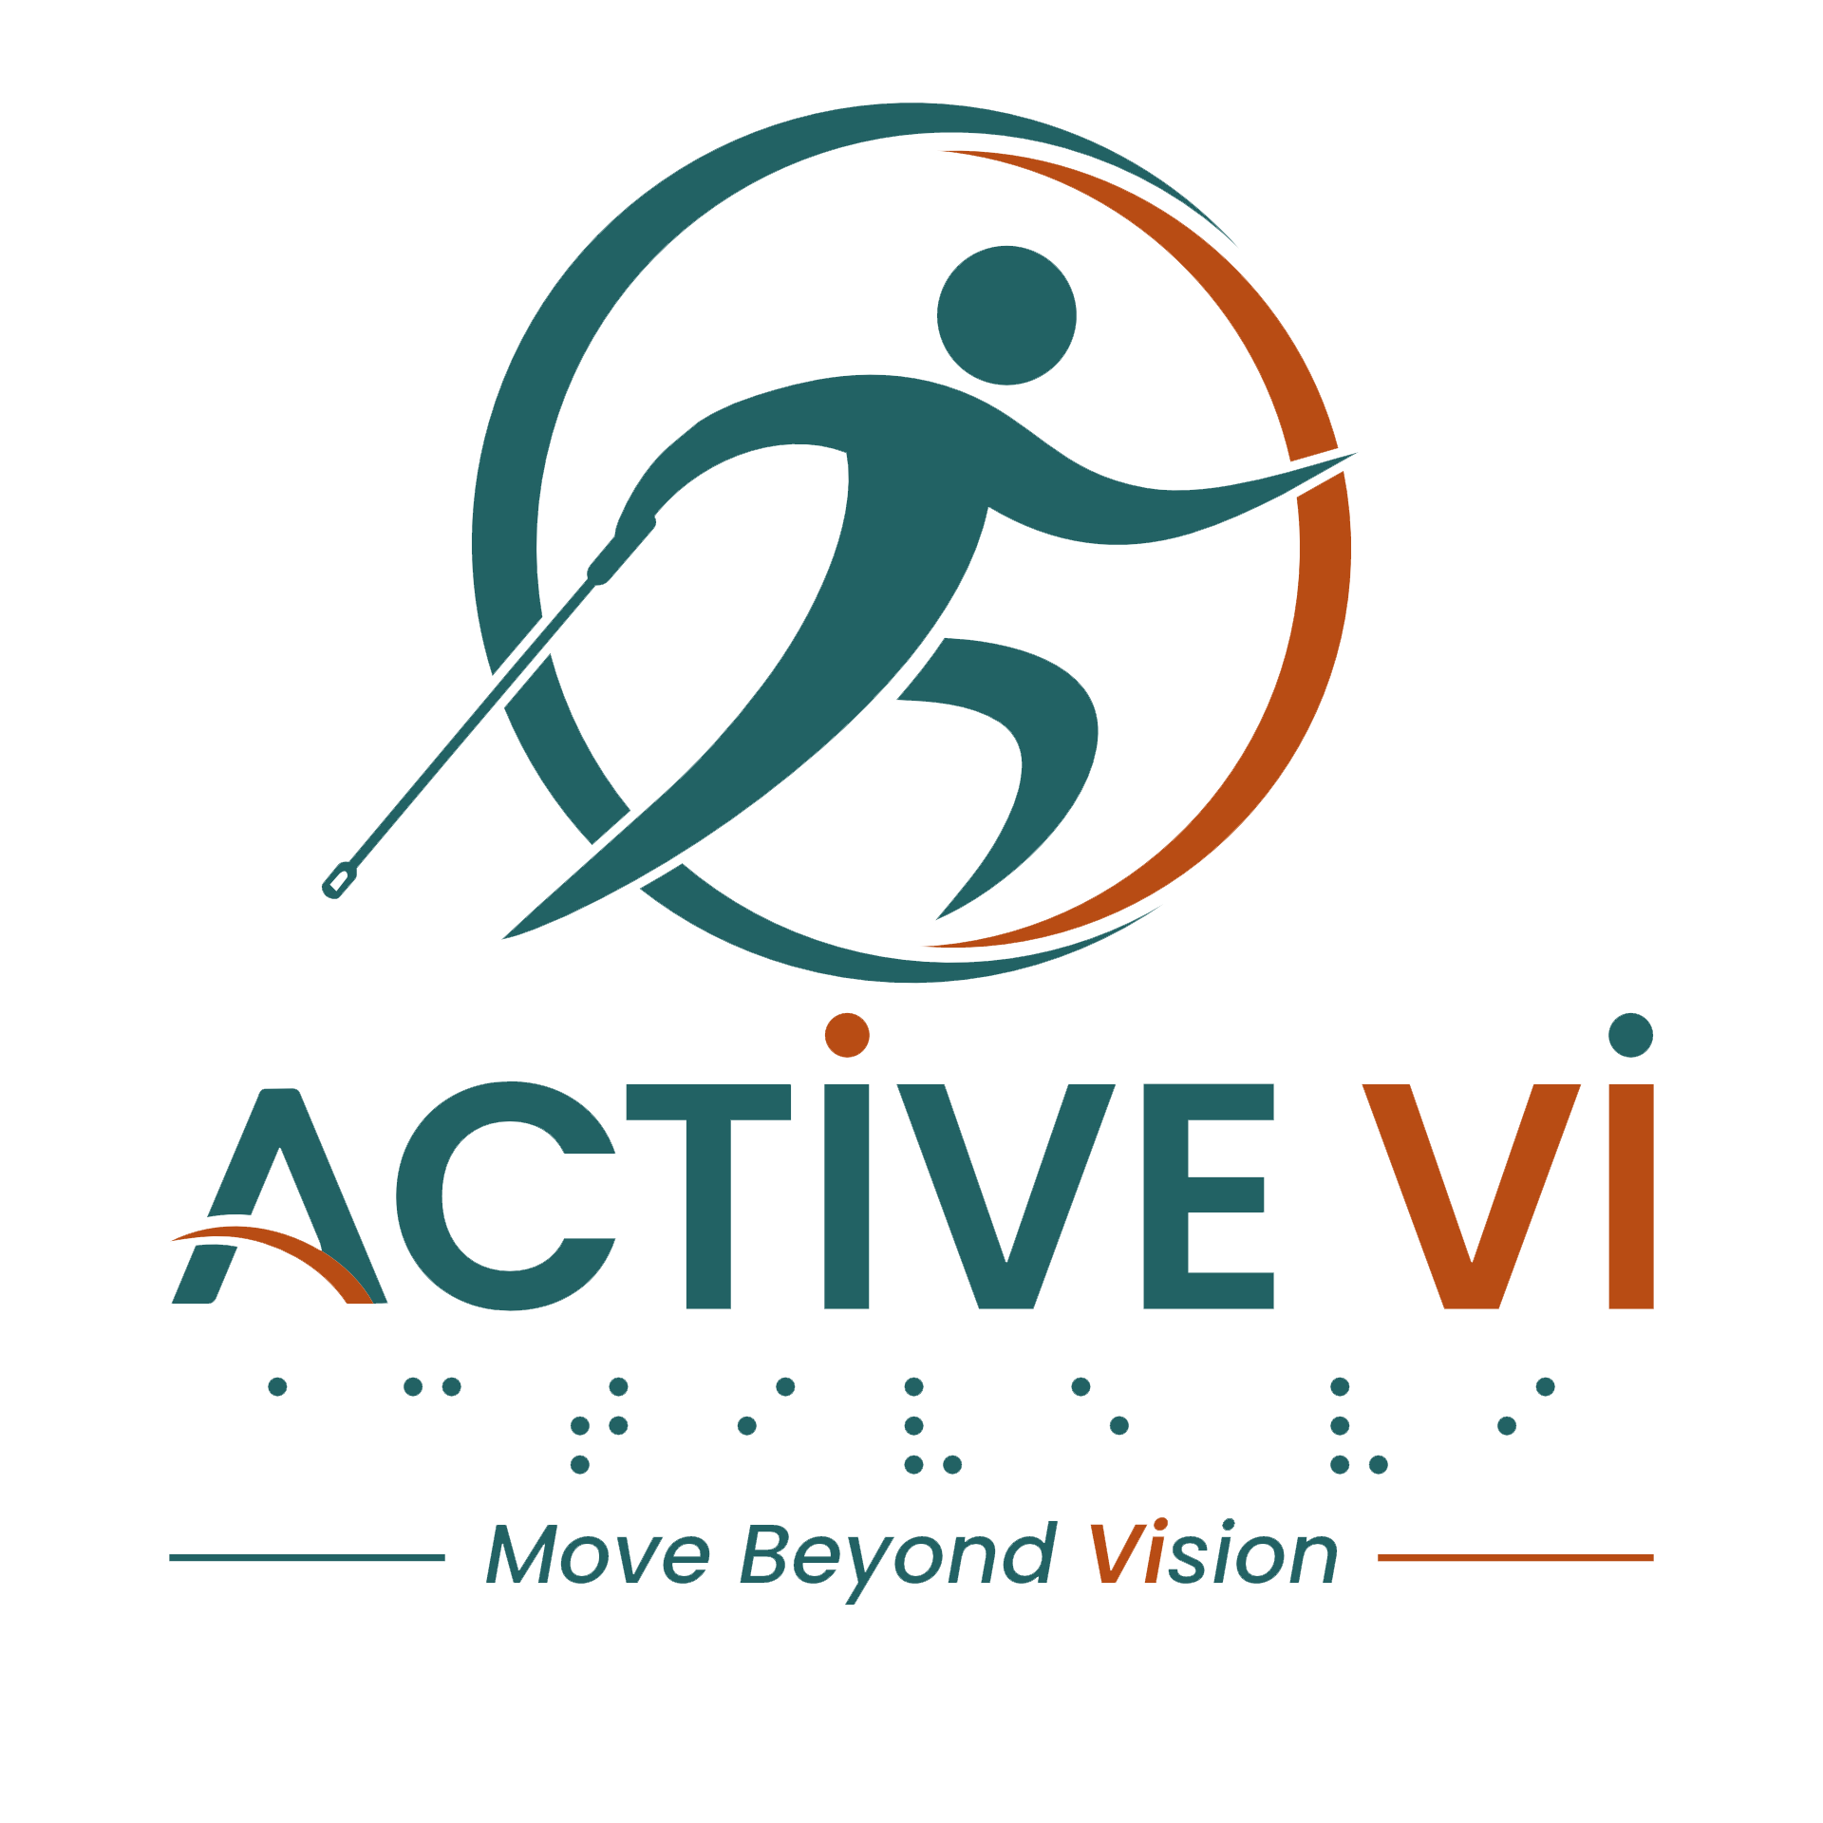

Podcast Episode 4 Transcript: Clear Cues and Good Guides: The Key to Inclusive Fitness.
Duration: 5.35 minutes
Listen to this ACTIVE VI Podcast episode on Spotify.

[Music: ACTIVE VI - Move Beyond Vision Jingle]
[Music fades]
Lydia: Hi Pei Pei!
Pei Pei: Hey, hi Lydia!
Lydia: I didn't know you were in class today. How you find today's class?
Pei Pei: Well, it was…still enjoyable, but I feel that there were times when the instructor could have been clearer.
Lydia: Yes, I agree with you. She didn't give clear instruction. And then I was like... um, you know, I don't know how to move. The movement I am not very sure.
Pei Pei: Well it was worse for me because I was standing at the back of the class. The music was so loud. I couldn't hear her clearly.
Lydia: Ah, ya... I also feel the same, today the music very loud. And then some more she didn't give clear instruction. I was like... um... okay, today is not going to make my day.
Pei Pei: I also felt quite distracted because people were speaking behind me, chit-chatting...
Lydia: Yes, I also hear that and I think she could able to, you know, control the class better.
Pei Pei: Yah, I thought she could have managed the class better, because it was so hard for me to concentrate.
Lydia: Yes, and it is…I find so disturbing. Today is not really my day. So how about last week?
Pei Pei: Oh, I really enjoy that session. The instructor was so clear and focussed.
Lydia: Yes, I agree. She gave clear instruction and I’m able to follow. And she know my name, she encourage me and say that Lydia you are doing well, I'm so happy.
Pei Pei: I think she knows everyone's names.
Lydia: Yes, that is so encouraging, right? She get to remember everybody's name.
Pei Pei: That gives it a personal touch.
Lydia: Yes!
Pei Pei: And you feel very motivated as well. She likes to go around and then to correct people, and to give encouragement. So if I am doing well, she'll let me know. If I am not doing well, or something wrong, she will actually tell me and guide me how to do it correctly.
Lydia: Yes, I agree with you, Pei Pei. I enjoy last week's lesson so much, you know, compared to this week.
Pei Pei: Me too. So what do you think makes a good instructor?
Lydia: She have to give clear verbal instruction, because we are VI. And then she have to have a loud voice, I mean the voice able to be clear and loud enough for us to follow. And she is able to manage the class, because we don't like other noises to interrupt the class.
Pei Pei: Yes, I agree with you. And I like that she actually makes us feel included and supported.
Lydia: Yes. I like it also.
[giggles]
Lydia: Pei Pei, how about today's volunteer? Did the volunteer actually help you to correct your posture?
Pei Pei: Oh, I really liked my volunteer today. I think she had jumping experience herself, so she noticed that I did the double bounce wrong. So she gently guided and explained it to me clearly. I really appreciate that very much. How about you?
Lydia: Okay, for me, today I don't have good experience with the volunteer. I think the volunteer, she's new with us today, and she's like more of observing. And she didn't actually gave me any instruction or never correct my posture at all.
Pei Pei: Yes, I think actually that really makes a big difference. I think if the volunteer has some experience or understanding, they will be able to provide better guidance.
Lydia: Yes, I agree. And I remember, I think the previous week or before, there's one volunteer that she's experienced, but she wasn't sure how to guide me. She touched me, and then I was like, "Eh, who touched me? Who touched my feet?” You know, it was suddenly she come behind me and touch me when she want to correct me. So actually gave me a shock.
Pei Pei: Yeah, I think a good volunteer should actually ask first, how would we like them to help us and guide us. Because each individual is different, some people will prefer more verbal, some people prefer touch.
Lydia: Yes, yes, yes, that is very important. Yeah. But hey, I have a friend who wanted to join the trampoline class. How can she get in touch with the registration?
Pei Pei: Oh, she can log on to the Active VI website at www.activevi.sg to read more about trampoline and other activities and how to join them.
Lydia: Oh, there's this website, I never know of! Okay, I better write down and then after that I'm going to pass it to my friend.
Pei Pei: Yes, you should log on yourself too.
Lydia: Yes, I think I will join other classes also like you mentioned got other exercise right? Okay, I will go in and check.
Pei Pei: Okay got to go.
Lydia: Okay, Pei Pei, I see you next week.
Pei Pei: See you next week. Bye.
Lydia: Bye.
Pei Pei and Lydia: ACTIVE VI – Move Beyond Vision.
[Music: ACTIVE VI - Move Beyond Vision Jingle]
[Music fades]
[End of transcript]

ABOUT ACTIVE VI: MOVE BEYOND VISION
ACTIVE VI is a movement co-designed with persons with visual impairment (PVI), fitness professionals, and volunteers to promote inclusive physical activity. We empower everyone to build inclusive fitness environments and support our community to Move Beyond Vision.

CONNECT WITH US & ACCESS RESOURCES
- Visit the ACTIVE VI Website & Adaptive Sports Directory
- Watch the ACTIVE VI YouTube Channel
- Listen to the ACTIVE VI Podcast on Spotify

