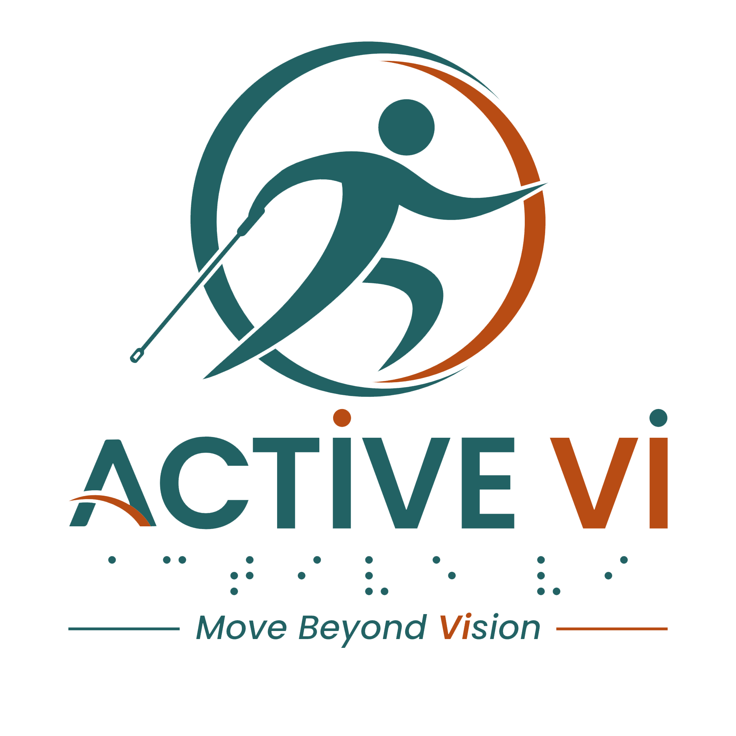

Podcast Episode 3 Transcript: Finding Your Pace – Running, Sighted Guides, and Self-Advocacy.
Duration: 5.17 minutes
Listen to this ACTIVE VI Podcast episode on Spotify.

[Music: ACTIVE VI - Move Beyond Vision Jingle]
[Music fades]
Sebastian: All right, Uncle James, in front of you at your 12 o'clock is your kopi, which you always drink regularly. And Verlyn, so nice to see you today, and this is your kopi siu dai, just right in front of you.
Uncle James: Oh, thanks, I got it.
Sebastian: Wa, it's been such a long time. Yes, ya, it's been ages, right? How have you guys been?
Uncle James: In fact, I just try to keep myself healthier, and also I try to learn something. Let's see what can the IT thing to help people like us.
Sebastian: So nice. Learning never stops, right? And Verlyn?
Verlyn: For myself, after becoming a mother of two young boys, I've been living a sedentary lifestyle. But recently in the past year, I've joined a running group that caters and promotes running to people of all abilities, even people with special needs. So, this running group, they have a sighted guide who guides low-vision like myself by using a tether or a lanyard to direct us in the right direction. When the guide sees passersbys or obstacles ahead of us, they will tug the other end of the tether to let us know should go in a specific direction.
Sebastian: Oh, this is news to me! Because as far as I know you, Verlyn, you have never been active. This is something that really spurs me into the fitness, I'm really interested in how they actually guide you safely through every run.
Verlyn: So these sighted guides, they make sure that I run safely throughout the run, and I've improved a lot since I've started. I do have some memorable incidents before as well. There was a guide who supposedly is trained to guide a visually impaired like myself. When she know that she is guiding me, she exclaimed, "Alamak!" And I said, "But I thought you are trained to guide visually impaired?” She said, “Yes, training is one thing and doing is another.” And I said, “If you are not comfortable guiding visually impaired, you can let the admin know." But she explains that she has guided visually impaired before, just not as bad.
Sebastian: Wah, that must been very intimidating for you, yeah.
Verlyn: I do not want to let the first interaction become something that spoils my run, so I try to give her constructive feedback. And along the way, as I bumped into people, after giving her feedback, she actually led me better, and I bumped into fewer people. At the end of the run, I thanked her, and I think she has improved overall.
Sebastian: I would think that these guides would have undergone some, you know, some intensive training even before the run, so that they can know the proper techniques to guide the visually impaired. Do you have something of this experience, Uncle James?
Uncle James: Actually, I understand all of them are in fact trained for the different PWD people. Honestly, vision impaired I think is quite complicated because everyone on a different level or different types of…
Sebastian: Spectrum…
Uncle James: Ya, expecting…So important thing I think is get to be understand each other. So my experience is I would like to explain to them first what is for me, what I need to.
Sebastian: Yeah, so you did a lot of self-advocacy for yourself. So as to make your run a more smooth pleasant one.
Uncle James: Yes.
Sebastian: That's cool.
Verlyn: Uncle James, you can actually come and try it out. If you do not like running, you can actually join the walking group. They have different groups to cater to different runners with different pace.
Uncle James: Yes, I'd like to... yes, now I can't really do the running, but for a brisk walk I think no problem.
Verlyn: Definitely.
Uncle James: Ya, I also like hiking lah.
Sebastian: So, Verlyn, did that experience really hinder you from…you know…continuing in this journey of running with this running group?
Verlyn: Not really, because of liking the activity. And I think that self-advocacy is very important for visually impaired. Everywhere we go, we need to advocate for ourselves…
Sebastian: Exactly.
Verlyn: Let people around us understand how they can better assist us.
Sebastian: That is so important. I mean, for us, we know, in order to make our running a pleasant one, I believe that it’s a two-way communication between ourselves as well as the guides. Ya, I'm really looking forward to the run because it's been a long time since I've been into the running [laugh]. So, I would, you know, really want to try that walking group just for a start. Maybe I can jio (invite) Uncle James to join me as well for the run. Ya, we can have another session of kopi after that.
Verlyn: Visit www.activevi.sg to get more info.
Sebastian: Great, I will not hesitate to sign up for our next run. All right, so cheers to our kopi then.
Uncle James: Thank you for the coffee ah.
Sebastian: No worries. Yah, it'll be on you on the next time! [laugh]
[Music: ACTIVE VI - Move Beyond Vision Jingle]
[Music fades]
[End of transcript]

ABOUT ACTIVE VI: MOVE BEYOND VISION
ACTIVE VI is a movement co-designed with persons with visual impairment (PVI), fitness professionals, and volunteers to promote inclusive physical activity. We empower everyone to build inclusive fitness environments and support our community to Move Beyond Vision.

CONNECT WITH US & ACCESS RESOURCES
- Visit the ACTIVE VI Website & Adaptive Sports Directory
- Watch the ACTIVE VI YouTube Channel
- Listen to the ACTIVE VI Podcast on Spotify

