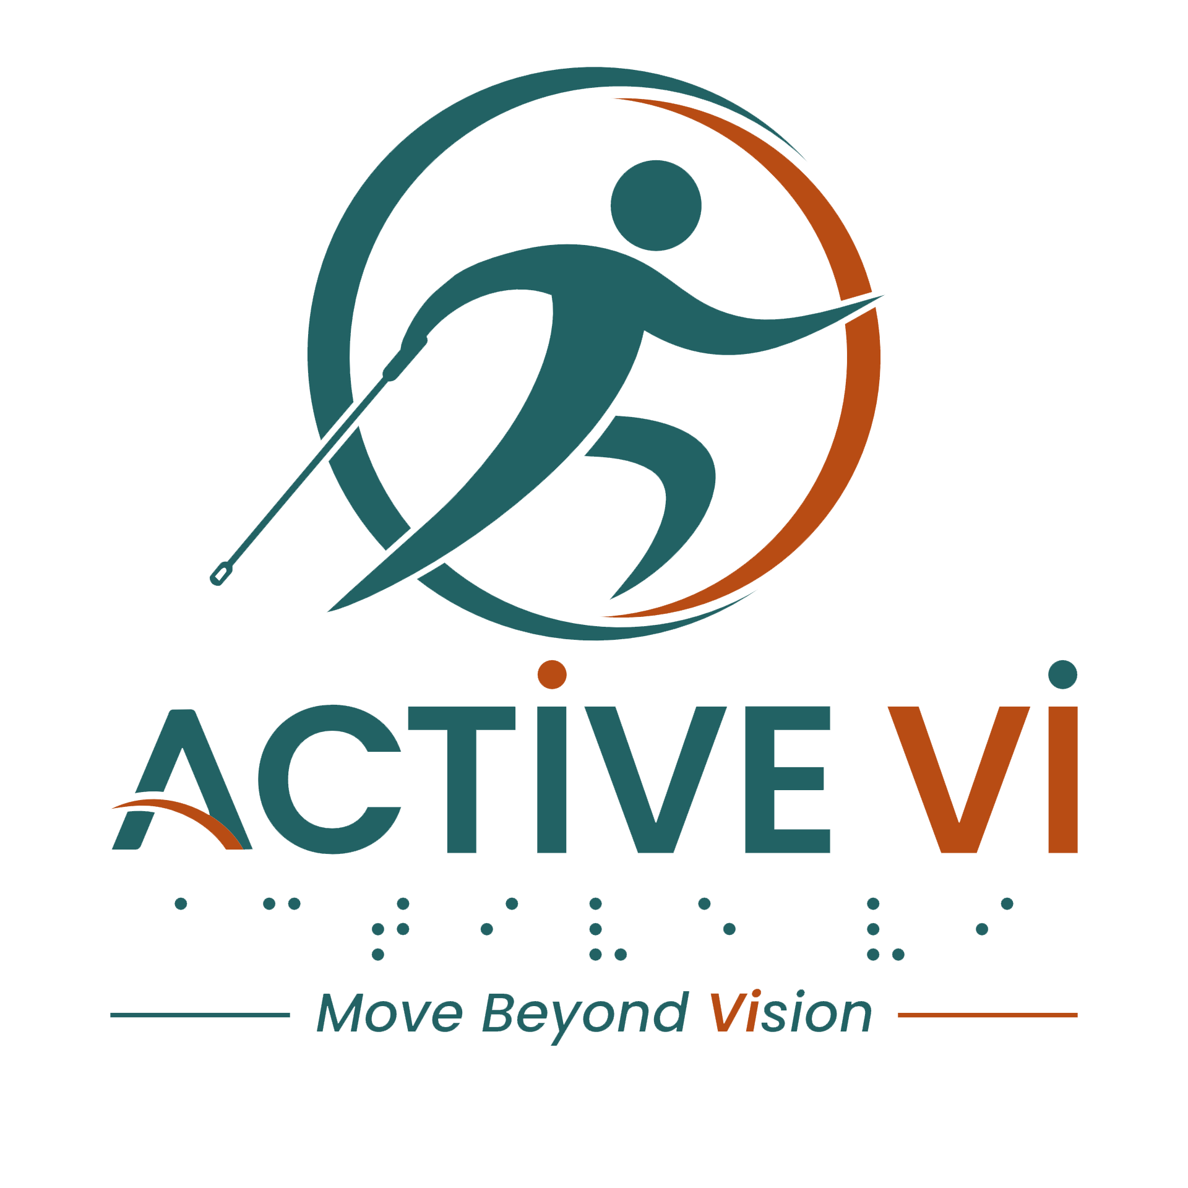

Podcast Episode 2 Transcript: From Safety Ropes to Supper: How PVI Rock Climbing Works.
Duration: 06.43 minutes
Listen to this ACTIVE VI Podcast episode on Spotify.

[Music: ACTIVE VI - Move Beyond Vision Jingle]
[Music fades]
[Background hawker centre ambience]
June: Hey, Dennard! Wah, I didn't know you are here leh.
Dennard: Ya! Wah, this chicken rice ah, must eat leh! Very nice leh. Come sit down, sit down, come eat together.
June: Eh, Yesterday ah, after rock climbing you go for supper, now you eat again?
Dennard: Ya lah, eat is my leisure! Every day must eat, ya, three meals a day, mine five meals!
June: Wah!
Dennard: Must eat more, because exercise a lot, mah! You also exercise a lot! So you must eat more!
June: I think you should go more rock climbing, man!
Dennard: Ya, aiyoh! Ya, I'm doing that, actually, but only a few slots only leh. Not easy to ballot leh!
June: Wah!
Dennard: Ya, but I always manage to ballot lah. Wah, must really on the clock one leh, must…
June: Wah, I must learn from you lah!
Dennard: Faster, fast finger, ya, must fast finger, all these things!
(Sound of approaching footsteps and chatter)
June: Is that Teh Lin over there?
Dennard: Ya, ya, ya! Eh! I also thought, eh, I also thought I saw Teh Lin. Beside is it?
June: I think so eh.
Dennard: Eh, want to go and sit with him? Say hello to him?
June: Aiyo, your usual psycho again!
Dennard: Ya lah, ya lah, no psycho! Go and sit down…
June: Was biang, You don't know invite how many people already, you know?
Dennard: Ya, let’s approach him. Mhm.
June: Okay lah, let’s go!
Dennard: Eh, hello, Teh Lin!
Teh Lin: Hello!
June: Hi Teh Lin!
Dennard: Wah, why you here?
Dennard: Wah, you eating also? Alone, ah?
Teh Lin: Ya, Dennard.
June: Eh, you know who we are or not?
Dennard: Mm!
Teh Lin: Ya, I know Dennard.
Dennard: Eh…
Teh Lin: Then who are you?
June: I'm June lah!
Teh Lin: Oh, June, I see!
Dennard: Wah, can we sit down together with you or not?
Teh Lin: Sure, sure, sit down, sit down!
Dennard: Okay, okay, come, let's sit, let's sit.
June: We join you.
Teh Lin: Ya, long time no see, ah!
Dennard: Ya..
June: Ya! You will see us more often if you come rock climbing with us.
Teh Lin: Rock climbing?
Dennard: Yes.
Teh Lin: Oh! Climb which hill?
[June laughs]
Dennard: No, not hill! We are climbing indoor one! It's wall, we are climbing wall!
June: Yes.
Teh Lin: Indoor also got hill one meh?
Dennard: No, it's wall, not hill! It's wall with pockets of rocks for you to hold on, climb climb climb to the top, then after that you can fly down!
Teh Lin: Wah, okay, explain slowly?
June: You feel the shape hah, got mushroom shape, got banana shape, got different-different kind of shape, very fun one!
Dennard: Yes….
June: Got watermelon also!
Teh Lin: Watermelon?
Dennard: Yes….
June: Ya!
Teh Lin: Oh, I see. But, how you all start the climbing?
Dennard: Orh, there will be a volunteer tag to us. So it's one-to-one. So the volunteer will be the belayer. She will be the belayer and the guide to teach you how to climb to the top of the wall. You will be tied to a rope and you will have a harness with you. So it's very safe. So the volunteer will actually guide you to the wall and help you to touch where is the rock to hold on to. Then slowly-slowly as you progress up, they will actually tell you in clock direction where is the wall and you just have to hold one step, one step at a time.
June: So, when they guide you, right, you will have the instructions, you know, the distance and the direction. It's not far away one.
Teh Lin: I see. How high is the wall?
Dennard: Oh, the wall about maybe…three storey HDB? But it's not very high.
Teh Lin: So high…
June: But they have different level lah, not to worry. You can start from level one. Then if you think that you can reach level two, then you can continue lah. Maybe you should start with level one first loh.
Dennard: Yes.
Ten Lin: I see. But just now you mentioned that there's guide guiding. So how do they actually communicate with you?
Dennard: There will be a earpiece tag to you and the guide. So the guide can actually use that speaker to speak to you when you're climbing high, so you will always hear his voice in the earpiece, and he will guide you from there.
Teh Lin: Oh. So you all say that there are different kind of shape for you to hold. But what if I grab wrongly?
June: No worries lah. The guide will actually tell you and give you directions. For example, oh, 11 o'clock, you know, move your leg to the left, or, you move your hand towards the right side. So they will actually correct you on the spot. So don't worry about that.
Dennard: Ya, and they will tell you where to grip the best grip. So they'll say it's above the rock or like the right side of the rock. So roughly, you still can feel before you hold on to the rock.
Teh Lin: But I quite scared leh. Ya, I’m very attached to my life, one leh.
Dennard: Ah, but the rope is attached to you. So your life is attached to the rope and it's attached to the volunteer. And the volunteer will be there to guide you safely down. So there's no problem in actually climbing up because you will be very safe because the rope is secured and you will feel like the rope is pulling you. So you can feel very secure, like when you're climbing up.
June: Eh, some more, ah, when you're hanging there, it's just like an angel flying!
Dennard: Yes, down from heaven!
June: Ya, you should really go and try lah.
Teh Lin: Mm. But I worry I will slip during the climbing.
Dennard: Ya but the rope will actually hold on to you with the harness. So when you slip, right, you can actually slip back, you will still be on that spot, you won't go down. So if you want to continue climbing, right, you can go back to the rock that you have hold on and you can continue to go up. If not, you don't want to continue, you feel tired, the guide can actually slowly belay you down.
Teh Lin: Oh, so I don't need to climb down myself?
Dennard: Don’t have to.
June: Give it a try, lah!
Dennard: Yes, give it a try! It's good, and there's a lot of VI over there as well. We are a community, so we will help one another to see what’s the best wall to climb, which one is good for you. Then we will be there to cheer you on.
Teh Lin: How do I even get to go there?
June: Oh, we have volunteers to guide you from Lavender MRT all the way to the outpost climbing.
Dennard: Yes.
June: Ya. Don't worry, just come. Ya.
Dennard: You'll be well taken care of.
June: Yes. And after rock climbing, makan session!
Dennard: Yes, that's what I having yesterday night. Ya, with the group of volunteers and VIs.
Teh Lin: How do I register?
June: You can go to activevi.sg, you know, to register and somebody will attend to you. Just give it a try lah.
Dennard: Yes.
Teh Lin: Oh, okay lah, okay lah. I'll consider.
June: Ah, don't consider lah, try one time lah.
Dennard: Ya, come join us once, ya, try it, ya, you never know.
Teh Lin: Okay, okay. Usually the session is on which day?
June: Last Friday of the month. So it'll be 7:00 PM to 10:00 PM. Eh, anyway, I stay near you lah, don't worry lah, we can go back together lah and accompany each other.
Dennard: Ya, the gym is very near to your place. It's just a MRT down.
June: Yes.
Teh Lin: Okay, okay. I try this Friday.
Dennard: Yes, I see you on Friday!
June: And after that we go supper, okay?
Dennard: Yes.
June: Alright!
[Group cheers and claps]
All: Active VI, move beyond vision!
[Music: ACTIVE VI - Move Beyond Vision Jingle]
[Music fades]
[End of transcript]

ABOUT ACTIVE VI: MOVE BEYOND VISION
ACTIVE VI is a movement co-designed with persons with visual impairment (PVI), fitness professionals, and volunteers to promote inclusive physical activity. We empower everyone to build inclusive fitness environments and support our community to Move Beyond Vision.

CONNECT WITH US & ACCESS RESOURCES
- Visit the ACTIVE VI Website & Adaptive Sports Directory
- Watch the ACTIVE VI YouTube Channel
- Listen to the ACTIVE VI Podcast on Spotify

