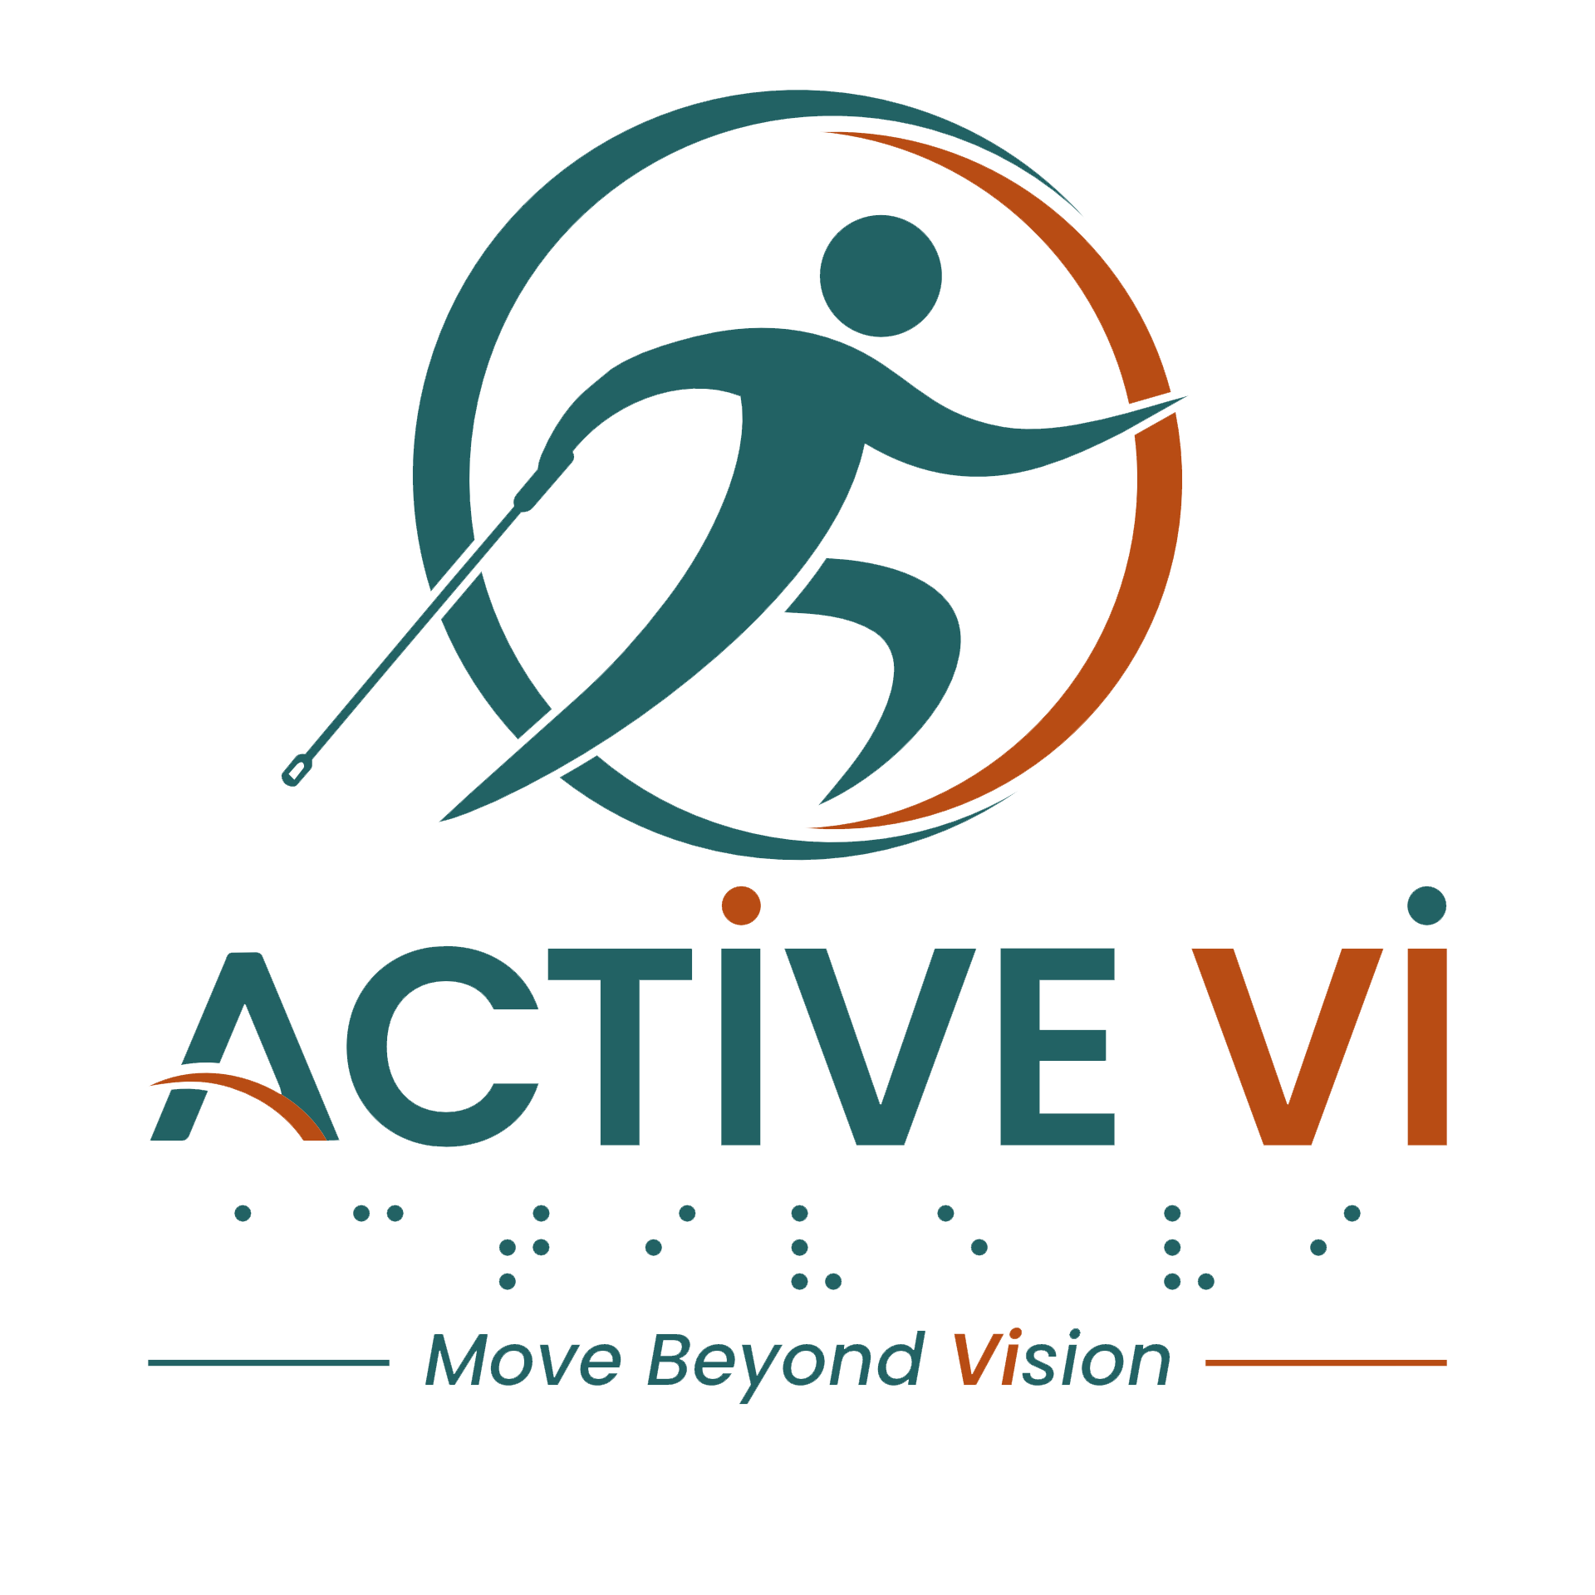

Podcast Episode 1 Transcript: Finding Friendship, Joy and Energy Through Exercises
Duration: 10.06 minutes
Listen to this ACTIVE VI Podcast episode on Spotify.

(Music: ACTIVE VI - Move Beyond Vision Jingle)
Verlyn: Hi everyone, my name is Verlyn and I'm in my 30s.
Sherri: Hi Verlyn. Uh I'm Sherri, I'm 57.
Pei Yueng: 大家好，我是佩莹，我已经60多岁了。
(Translation: Hello everyone, my name is Pei Yueng, and I am in my 60s.)
Verlyn: Oh, very nice meeting both of you.
Sherri: Yeah, nice meeting…
Verlyn: I am mother of two young boys and suffer from retinitis pigmentosa together with cataract and night blindness.
Sherri: Why…I have retinitis pigmentosa too.
Pei Yueng: Oh, 我也是, 我也是 RP。
(Translation: Oh, me too, I have RP as well.)
Sherri: Ya, all of us are RP.
Veryln: I see. Uh I actually enjoy workout a lot recently. Initially, I didn't really want to do the workout, but I thought that it's not going to be healthy if I continue to just be working and going back to take care of children. The next day I start to work again, there is no work-life balance at all. How about you guys?
Sherri: Ya, I love working out. It makes me happy after the workout.
Verlyn: Uh-huh.
Sherri: Ya, before that I used to feel sluggish, but with a lot more exercising, ya, I feel more ready to tackle problems. [giggle]
Verlyn: And what kind of workout do you do, Sherri?
Sherri: Mmm…I like indoor walking, uh I like mini trampoline and Pilates. But um I fractured my foot about three months ago, so I had to switch to the mini elliptical now.
Verlyn: I see, 那你呢？佩莹
(Translation: How about you, Pei Yueng?)
Pei Yueng: 我在还没做这些运动之前，我整天就是躲在家里看电视，可以看到五六个钟头。自从LMP的Programme进来了，介绍我们一定要多运动。我现在目前在那个健身院做瑜伽，然后我也有参加那个Pilates。这就是我的主要的活动。
(Translation: I wanted to say that before doing these exercises, I used to hide at home watching TV all day. I could watch for five to six hours straight. But ever since the LMP programme came in and introduced that we must exercise more, now I do yoga at the fitness centre, and I also participate in Pilates. These are my main activities.)
Verlyn: So I see Pilates is one thing that we all enjoy a lot. I've completed nine sessions of reformer Pilates and I like it a lot too.
Pei Yueng: 我觉得这个Pilates对我们的那个core的帮助很大，所以我就继续在参加。而且这个至少有用到很多力啊。我的cardio比较不好，所以我要加强这一部分。
(Translation: I feel that Pilates helps our core a lot, so I continue to participate. Moreover, it requires quite a lot of physical effort. My cardio is quite weak, so I need to strengthen this part.)
Verlyn: So I feel that Pilates is very useful for me because it helps me to control my breathing and incorporate all my stress in the week for like work and home duties. It helps me to relax a lot more compared to before.
Sherri: Ya, I love the stretching, the feel it gives me after the workout, it's nice.
Verlyn: Yes.
Sherri: Ya.
Verlyn: So Pei Yueng, 刚才你聊到说你的cardio不是很好, 你有没有考虑说想要去散步或者跑步呢？
(Translation: So Pei Yueng, earlier you mentioned that your cardio isn't very good, have you considered going for walks or running?)
Pei Yueng: 哦, 对我来讲跑步是一大挑战。而且我每次跑到一半就气喘如牛，所以我就不太想要做……
(Translation: Oh, running is a huge challenge for me. Every time I run halfway, I get completely out of breath, so I don't really want to do it…)
Verlyn: 其实如果刚开始你可能不能跑很多，可是呃如果你每个星期多跑稍微一点点，慢慢你的cardio，你的stamina就会变好一点。你可以先试着快走，慢慢才慢跑。
(Translation: Actually, when you start out, you might not be able to run much, but if you run just a little bit more each week, slowly your cardio and stamina will get better. You can try brisk walking first, and slowly move on to jogging.)
Verlyn: When I first started running in September or October last year, I couldn't even run 1 km. I felt very breathless and even felt like fainting.
Sherri: Oh…
Verlyn: but slowly I improve in distance and time. Um I slowly improve to 2 km and 3 km without stopping. Now I am able to run um 6.5 to 7 km without stopping on good days. Um now that I have been working out regularly, I feel a lot happier and energised. I feel a lot more confident as well.
Sherri: Oh, that's amazing. I can’t even run [giggle] to the bus stop.
Pei Yueng: 可是问题是时间的关系。我看你们每次跑步都是在清晨。清晨的时间我不允许啊，因为我、我还有工作啊，我有做part-time的工作。所以早上的时间都根本不可以。如果要晚上呢，我又很早睡，第二天要早起，所以时间对我来讲是一大挑战。
(Translation: But the issue is time. I see that you guys always go running in the early morning. Morning time is not possible for me because I still have work; I do part-time work. So morning time is completely out of the question. As for the evening, I sleep very early and need to wake up early the next day, so time is a huge challenge for me.)
Verlyn: 对, 明白。其实刚开始我也是这样，然后后来慢慢想说我要怎样去安排我的时间来配合我能够有一点时间给我自己运动。
(Translation: Yes, I understand. Actually, I was like that at the beginning too, and then I slowly thought about how to arrange my time to fit in some exercise for myself.)
Pei Yueng: 所以我就去参加那个呃健身院里面的那个yoga class，因为我觉得它给我们flexibility，那个时间最适合我，所以我就去参加了。开始是我的朋友会带我去，But我觉得她住得太远，所以我就觉得我应该尝试自己去那个健身院。所以现在渐渐地我已经开始不需要她的帮忙，自己走去健身院。可是问题是我碰到一个大的挑战，就是要过那个十字路口。每次给我很大的难题，But最近我都碰到很多好心人。他们每次看到我犹豫不决，他们会帮我、带我去过那个健身院。所以我非常感激他们。
(Translation: So I went to join the yoga class at the fitness centre because I felt it gave me flexibility, and that time slot suited me best, so I joined. At first, my friend would bring me, but I felt it was too far away for her, so I decided I should try going to the fitness centre on my own. So gradually, I no longer need her help and can walk to the fitness centre myself. But the problem is I face a major challenge: crossing that crossroad. It always gives me a big headache, but recently I've met a lot of kind-hearted people. Every time they see me hesitating, they help me and guide me across to the fitness centre. So I am very grateful to them.)
Verlyn: Working out, uh I feel that it's also something that makes me very happy, not just because of the fitness level improving, but also because of the friends and people that we meet.
Sherri: Yeah, I agree. I met so many since starting this project. Um…Dennard, Jason, you, I mean I met you so many years ago, but we didn't really get to being friends until this project.
Verlyn: So I think that um the social interaction, like maybe after our workout session at the gym, we hang out together for coffee or maybe even like go for a movie. All this actually helps me to look forward to the next exercise session.
Sherri: Ya, that's right. The exercise is one hour and then the...
Verlyn: Yes, the hanging out is probably four hours.
Pei Yueng: 你讲得对了，因为星期五我们上完了那个Pilates，他们都会说提议去吃午餐。因为我们的Pilates是两点才完，所以通常都是在上完了课，我们就一起去那个小贩中心啊，吃午餐啊，谈天说地啰。这个可以增加我们朋友的圈子。社交圈子会增广，就是好过你独自一个人去做一个活动啊。
(Translation: You are right, because after we finish our Pilates, everyone suggests going for lunch together. Because our Pilates ends at 2 PM, usually right after class we go together to the hawker centre, have lunch, and chat about everything. This can increase our circle of friends. Our social circle expands, and well, it's better than doing an activity all by yourself.)
Verlyn: 赞同。
(Translation: Agreed.)
Pei Yueng: 呀，对。
(Translation: Yeah, right.)
Verlyn: I feel that my friends have definitely been my motivation from the start. I wouldn't have come so far without them.
Sherri: Ya, I agree. I think it's them, it's friends who push us.
Verlyn: Yes.
Pei Yueng: Ya，他们是（因为）朋友，我是在老师的鼓励下，我才去想动的。不然她说你整天躲在家里没有动，对你的健康也不好，所以我的那个成绩单每次很差的。好像验血报告出来这个不好、那个不好，要你吃药。所以我觉得不然我就做一点运动，因为现在新加坡的老人越来越多有肌少症，muscle less啊。所以我觉、我觉得我不想、很快得到这个病症，我就觉得应该开始运动了，因为我的年纪也不小了。因为是有老师的鼓励，我才会提起勇气去参加那些活动。刚刚开始，你一切都很生疏，你会觉得那环境很陌生，再加上不知道那边的人会不会帮你拿那个瑜伽的那个mat啊，还有拿那个block啊，这些都是要慢慢来。开始他们不熟悉你，他们就会好像不当一回事啊。过后渐渐地他们会开始帮忙你，帮你拿这个拿那个，你会建立起一点信心啦，因为至少有朋友帮忙嘛。这样你做那个运动时候又有老师在旁指导的话，你的信心会一天比一天好。所以我就每次推动自己，必须要去瑜伽课。这样渐渐地我就对那个瑜伽开始有信心，就慢慢地爱上那个瑜伽课了。再來就是我的那个瑜伽老师，他对我特别好。我有跟他讲我的眼睛有问题，我是用耳朵听他讲。我不可以看到他的动作。所以他每次看到我姿势不对，他会从那个台上跳下来，纠正我姿势再跳上去，再做示范。这一点我觉得我很感激他。可能就是因为有这种推动力，让我一直继续参加到现在。
(Translation: Ya, they are (because of) friends, and for me, it is because of the encouragement of the teacher, I wanted to move. Otherwise, she said, if you hide at home all day without moving, it's not good for your health, so my medical report cards were always very bad. Moreover, the blood test reports showed this was bad, that was bad, and required me to take medication. So I thought I might as well do some exercise, because now there are more and more elderly people in Singapore experiencing sarcopenia (muscle loss). So I felt I didn't want to get this condition so quickly, and I thought I should start exercising since I am not that young anymore. Because of the teacher's encouragement, I summoned the courage to participate in those activities. In the very beginning, everything is unfamiliar to you, you feel the environment is new, plus you don't know if people there will help you get your yoga mat or blocks, so these things take time. At first, they aren't familiar with you, and they might seem indifferent. Afterwards, gradually they start helping you, helping you get this and that, and you build up a bit of confidence because at least you have friends helping. When you do the exercise with a teacher guiding you by your side, your confidence gets better day by day. So, I push myself every time that I must go to yoga class. Gradually, I gained confidence in yoga and slowly fell in love with it. Furthermore, my yoga teacher is exceptionally good to me. I told him I have eye problems and that I listen to his instructions with my ears since I cannot see his movements. So, every time he sees my posture is incorrect, he jumps down from the stage, corrects my posture, and jumps back up to continue teaching. This point is something I am very grateful to him for. Perhaps it's because of this driving force that has allowed me to keep participating until now.)
Sherri: But you're right, I like I like when we have instructors who understand our condition. You know, you don't feel left out in a class and…and you know you're doing it properly and there's someone to guide us. Nice having the friends around us, but the instructor is so important. Uh even the trampoline instructor is so good, Pilates instructor is so good, chair yoga. It makes me feel more confident, not shy about doing something wrong in front of a class. And it is…it's nice to be with visually impaired people because if I do it wrong, no one can see that I'm doing it wrong. [giggle]
(Music: ACTIVE VI - Move Beyond Vision Jingle)
[End of transcript]

ABOUT ACTIVE VI: MOVE BEYOND VISION
ACTIVE VI is a movement co-designed with persons with visual impairment (PVI), fitness professionals, and volunteers to promote inclusive physical activity. We empower everyone to build inclusive fitness environments and support our community to Move Beyond Vision.

CONNECT WITH US & ACCESS RESOURCES
- Visit the ACTIVE VI Website & Adaptive Sports Directory
- Watch the ACTIVE VI YouTube Channel
- Listen to the ACTIVE VI Podcast on Spotify

