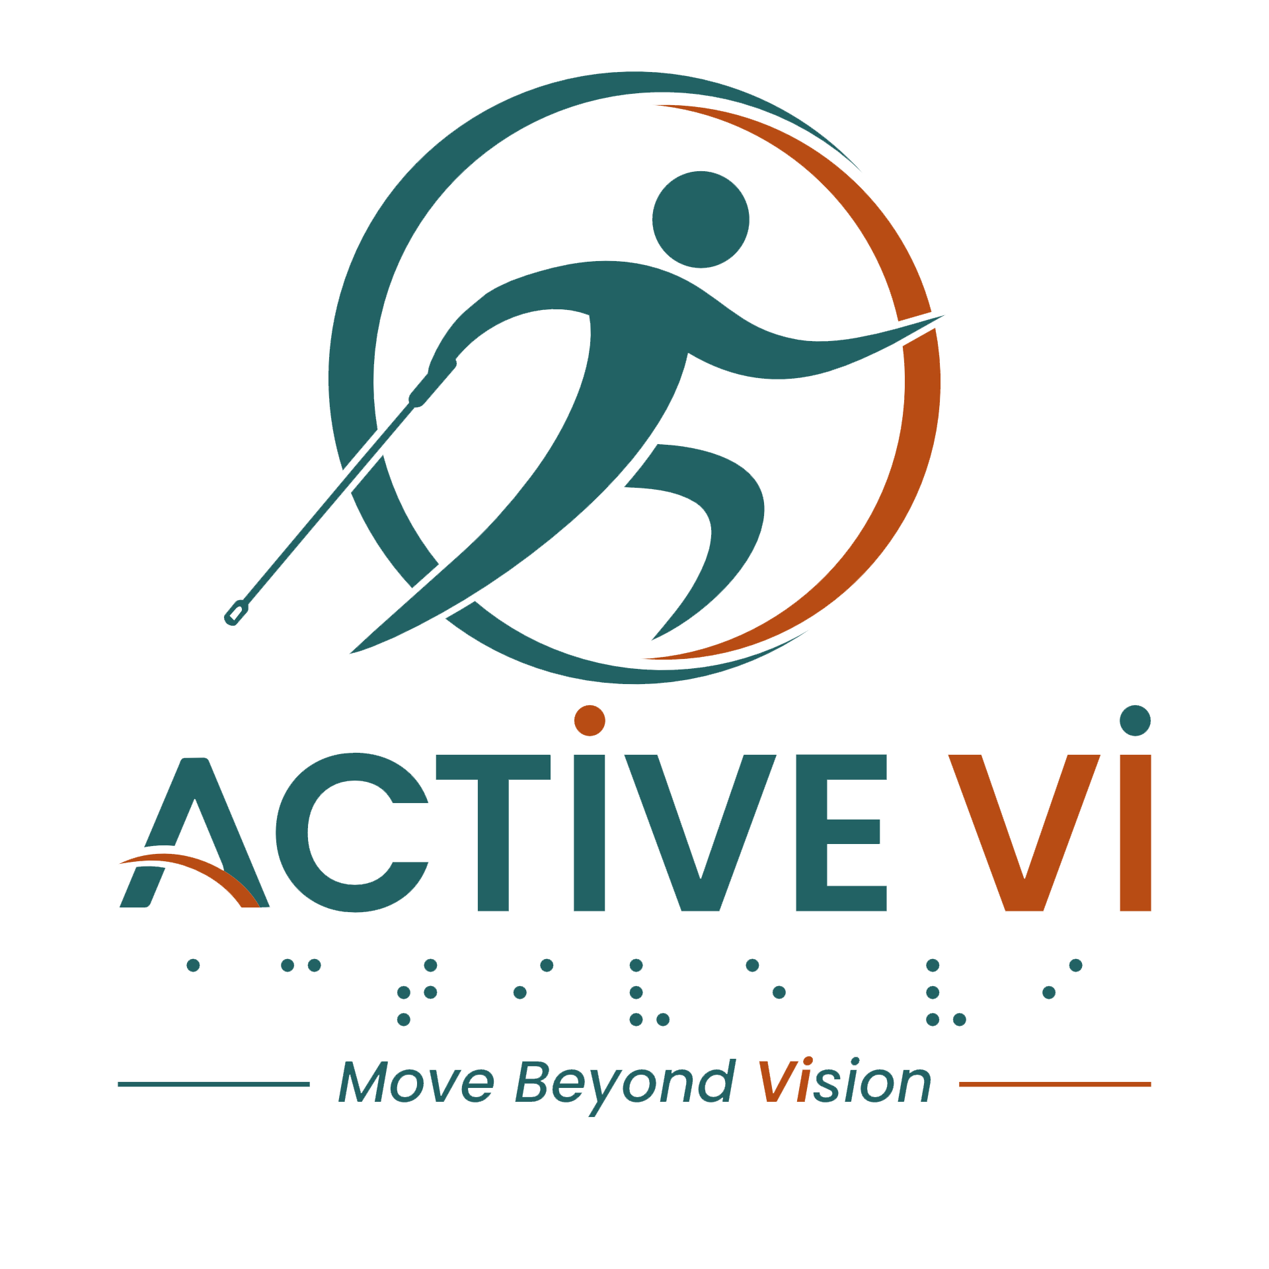

Transcript: FITNESS PROFESSIONAL - The Vision Behind Inclusive Pilates
Duration: 4 mins
Watch the Video: Fitness Professionals – The Vision Behind Inclusive Pilates on YouTube.

[Visual: ACTIVE VI - Move Beyond Vision logo appears on screen along with the website www.activevi.sg. The title text reads: FITNESS PROFESSIONAL - The Vision Behind Inclusive Pilates.]
[Visual: A bright Pilates studio with reformers. Several participants, including an ACTIVE VI participant, are stretching and moving on the machines under the guidance of a trainer.]
[Visual: Steven Kuan, Pilates Trainer, speaks to the camera. Cutaways show Jason lying on a reformer machine preparing for exercises and wiping down equipment with another participant.]
Steven Kuan: I think we're living in a society, in a small country where we are living very close to each other. And inclusivity is not just there are physical impairments and there's also intellectual impairments.
[Visual: Jason, an ACTIVE VI Participant, walks into The Pilates Works studio using his white cane, neatly stores his cane and shoes, and checks a locker.]
[Visual: Steven Kuan speaks to the camera again. Cutaways show him coaching Jason and other participants in the Pilates studio.]
Steven Kuan: Well, for Jason, I think he is one of the students from the VI class that has progressed very well. And the whole idea when we first started out is that the vision is that one day any of them can join a normal class. But in order to do that, they have to be prepared for it. So Jason has gone through 10 lessons. In the 10 lessons, it started off initially very slow. Every single step, it's like teaching a baby how to walk, to run. But the whole idea is that once they have been taught the basics, they know what to be done.
[Visual: Cutaways show Jason adjusting springs on his reformer machine and performing bridge exercises with Steven's guidance.]
[Visual: Steven continues speaking to the camera, explaining basic training and individualised support.]
Steven Kuan: So what you saw is Jason who has been trained. So when I say I want a box on it, it's like any other student knows how to put the box there, but that he worked hard getting there because he had to first learn everything because it's not easy to know how to put things when you can't see it.
[Visual: Cutaways show Jason setting up a box on his Pilates reformer machine independently, and performing prone extension exercises with straps; Steven is guiding other sighted student while giving instructions to the class]
Steven Kuan (background): Exhale coming back, and last one pushing out, then come back in and stop.
[Visual: Steven speaks to the camera about teaching style, class ration and attentiveness.]
Steven Kuan: Well, I guess a good teacher is always alert, looking across. If you notice, I move around to different students. So it's important to move around and the ratio in the class is great. The maximum we have in the class is only eight. So it allows a good ratio between teacher and student. So you see that what's important is as we do and then the student know what they're doing, we moved on. So you notice I don't need to just focus on Jason. He knows what it is. I make some small corrections. He carries on the exercise and on his own, and I move on to other students that may need some minor corrections.
[Visual: Cutaways show Jason and other students moving dynamically on the reformers, adjusting straps, and maintaining core control.]
[Visual: Steven discusses body language and reading student confidence.]
Steven Kuan: I guess you can see from their body language. If they are uncertain, you can see that they don't know what's going on and they are confident, they move with confidence and with flow. So I guess you see in the person, if they know what's happening, they move with confidence and if they're uncertain, then they may require some teachers' tactile cue and gentle reminders so they know what it is.
[Visual: A group of ACTIVE VI participants wearing matching "I am ACTIVE VI" white t-shirts sit on reformers in the studio, smiling and interacting.]
[Visual: Cutaways show Jason performing side-lying and rotational stretches on the reformer machine wearing his branded t-shirt.]
[Visual: Steven speaks to the camera about accepting disability and community integration.]
Steven Kuan: Well, the truth is that we have to accept the fact that the VI community have visual impairment. So it could be anything from low vision to being blind. So obviously, if they were to go straight into a normal class, the transition is too fast for them. But given preparation, they could be equipped.
[Visual: A group of ACTIVE VI participants enter the studio through the glass door, laughing, organising their shoes, and navigating the space using their white canes.]
[Visual: Steven speaks to the camera about participant empowerment.]
Steven Kuan: The vision when we started the program was not about a teacher facilitating the class, but them being empowered to own the exercise and the movement. And it begins from the moment they step into the studio. They learn where to put the shoes, they learn where the cupboards are, they find their way to the bed, they memorise which beds they have, so that it was never a case of "I will lead you there."
[Visual: Close-up of Jason folding his white cane and adjusting equipment components independently.]
[Visual: Steven speaks to the camera about Pilates benefits for individuals with visual impairments.]
Steven Kuan: Yeah, I think one of the key things about Pilates is that we bring to them awareness of the body, bring about them the balance, the control, which are movements that are not coming easily when you have a visual impairment. So through Pilates, they become more aware of the body, they have more control, which it leads to a better quality of life because they can move more freely, more confidence, and they're more aware of space around them.
[Visual: Cutaways show Steven guiding Jason through a deep lateral stretch on the reformer, adjusting his arm placement.]
[Visual: Steven gives concluding remarks to the camera.]
Steven Kuan: So likewise, you know, as much as we can as trainers and the support that we are involved in, we embrace them and bring them in because we want them to feel a part of the community.
[Visual: Music: ACTIVE VI - Move Beyond Vision Jingle plays.]
[Visual: The ACTIVE VI - Move Beyond Vision logo appears on screen along with the website www.activevi.sg.]
[Visual: The End Credits display on screen: Led by Singapore Institute of Technology (SIT) Health and Social Sciences. In Collaboration with Guide Dogs Singapore and Singapore Association of the Visually Handicapped (SAVH). Supported by Enabling Lives Initiative (ELI) Grant by SG Enable & Tote Board. Text displays the grant and copyright disclaimer: The video was produced by Enabling Lives Initiative Grant, with support from SG Enable. It is not to be reproduced in part or in whole, without the written permission of Tote Board and/or SG Enable]
[Visual: Text displays: Special Thanks to: Participants and volunteers who contributed to the project, The Pilates Works, Everyone supporting inclusive fitness and community connection.]
[End of transcript]

ABOUT ACTIVE VI: MOVE BEYOND VISION
ACTIVE VI is a movement co-designed with persons with visual impairment (PVI), fitness professionals, and volunteers to promote inclusive physical activity. We empower everyone to build inclusive fitness environments and support our community to Move Beyond Vision.

CONNECT WITH US & ACCESS RESOURCES
- Visit the ACTIVE VI Website & Adaptive Sports Directory
- Watch the ACTIVE VI YouTube Channel
- Listen to the ACTIVE VI Podcast on Spotify

