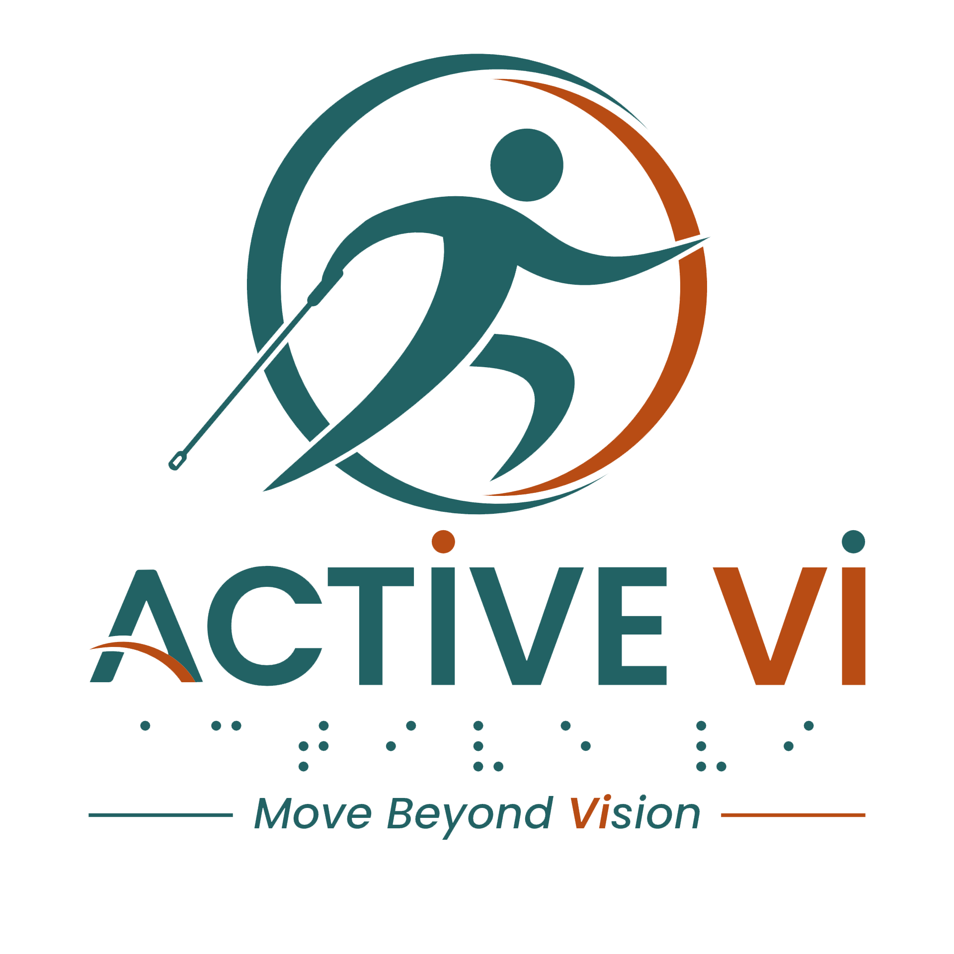

Accessible Exercise Guidance Checklist for Fitness Professionals & Volunteers
Document last updated: 2 August 2026
Welcome! Thank you for supporting inclusive fitness at ACTIVE VI. This checklist is designed to help trainers and volunteers guide participants with visual impairment (PVI) safely, respectfully, and effectively before, during, and after each exercise. Clear language builds confidence, independence, and trust.

Before the Exercise
- Introduce yourself and your role.
- Ask participants if they have any medical or physical condition to inform the trainer.
- Explain what exercise or pose will be practiced.
- Ask if the participant is familiar with the movement.
- Ask how they prefer to receive guidance (verbal only, or verbal plus touch).
- Ensure the space is clear of obstacles.
- Establish a directional reference (e.g., using the clock system).

While Giving Instructions
- Use clear, specific, and descriptive language.
- Name body parts instead of using visual cues.
- Give directions step by step.
- Use consistent reference points (clock directions, floor, mat).
- Avoid vague words like “here,” “there,” “this,” or “like that.”
- Offer options and modifications.
- Remind participants they can pause or ask questions at any time.
- Speak at a calm, steady pace.

Safety & Support
- Emphasise balance and stable footing.
- Give verbal warnings before transitions or changes in movement.
- Avoid forcing a range of motion.
- Never move someone’s body without their explicit consent.
- Respect personal space and autonomy.

After the Exercise
- Clearly explain how to safely come out of the movement.
- Ask how the exercise felt for them.
- Invite feedback on your instructions.
- Thank the participants for their effort and time.
Key Reminder: Accessible instruction is not about doing more. It’s about doing better. Clear language builds confidence, independence, and trust.
Visit the ACTIVE VI website for more inclusive fitness resources.

